

**WOLDIA UNIVERSITY**

**FACULTY OF TECHNOLOGY DEPARTMENT OF COMPUTER SCIENCE**

**Project Documentation on Web Based Human**

**Resource Management System for Woldia University**

**By: Section 1 group10**

|  |  |  |  |  |
| --- | --- | --- | --- | --- |
|  | **Name** | **ID** | **Email** | **Phone Number** |
| **1** | **Daniel Tefera** | **FOT(R)1699/08** | **danieltefera14@gmail.com** | **0919319791** |
| **2** | **Biruk Debebe** | **FOT(R)1665/08** | **birukdebebe432@gmail.com** | **0946630304** |
| **3** | **Alelign Kebede** | **FOT(R)1649/08** | **alexof211@gmail.com** | **0927412579** |
| **4** | **Kasim Misganaw** | **FOT(R)1806/08** | **kassimisge@gmail.com** | **0935261724** |
| **5** | **Ayalnesh Tsehaye** | **FOT(R)1667/08** | **ayaltseyeshi@gmail.com** | **0939300187** |
| 6 | **Habtam Dessie** | **FOT(R)1778/08** | **habtamdessie1@gmail.com** | **0988305981** |

**Project documentation submitted in partial fulfillment for the bachelor Degree in Computer Science**

**Advisors**

Advisor: Demeke Getaneh (MSc)

Co-Advisor: Fasil Alemu (BSc)

June 18, 2019

Woldia, Ethiopia

**Woldia University**

**Faculty of Technology**

**Department of Computer Science**

A Project Documentation On:

Web Based Human Resource Management System for Woldia University

|  |  |  |
| --- | --- | --- |
| **No.** | **Student Name** | **ID No.** |
| 1 | Daniel Tefera | FOT(R)1699/08 |
| 2 | Biruk Debebe | FOT(R)1665/08 |
| 3 | Kassim Misganaw | FOT(R)1806/08 |
| 4 | Alelign Kebede | FOT(R)1649/08 |
| 5 | Ayalinesh Tsehaye | FOT(R)1667/08 |
| 6 | Habtam Dessie | FOT(R)1778/08 |

Advisor Name and signature

1. Demeke Getaneh___________
2. Fasil Alemu __________

Examiner Name and Signature

1. ________________________
2. ________________________
3. ________________________
4. ________________________

# **Acknowledgment**

First of all we would like to thank **GOD** for helping us to reach this time and do this project. After that we would like to thank our advisors Instructor **Demeke Getaneh (MSc)** and **Fasil Alemu (BSc)** who contributed in giving their continuous advice and comments for this project. Finally, we would like to thank the WLDU human resource office manager Ato Alemu and employees especially w/ro Roman and Ato Awol, for giving us the necessary information about how the current system is working.

# **Abstract**

This proposed system is designed for WLDU human resource office to facilitate the current manual system. In this proposed system we used different data gathering methodology like interview, observation, discussion and documents since they helps us a lot to know the existing system work flow. We used object oriented approach in system analysis and design methodology part since it is power full than the other approach like from the structural and procedural. Our system development model is incremental model the reason that is why we select this model is since it allows us to go forward and backward when we get a customer feedback even if we do not complete implementing the system. To develop this system we are using different hardware and software. This system will develop using PHP programming language. This proposed system is also technically, economically, operationally feasible. In the modeling part we are using UML diagrams to analysis the system. After all when this proposed system is developed and deployed it will solve many problems of the existing manual system.

**Contents**

**Acknowledgment** i

**Abstract** ii

**List of tables** vii

**List of figures** viii

**Acronyms and abbreviations** x

**CHAPTER ONE** 1

**INTRODUCTION** 1

**1.** **Introduction** 1

**1.1** **Background of Woldia University** 2

**1.2** **Motivation** 3

**1.3** **Statement of the problem** 3

**1.4** **Objective** 4

**1.4.1** **General objectives** 4

**1.4.2** **Specific objectives** 4

**1.5** **Literature review** 5

**1.6** **Scopes and limitations of the project** 5

**1.6.1** **Scopes of the project** 5

**1.6.2** **Limitations of the project** 5

**1.7** **Methodology** 6

**1.7.1** **Data gathering techniques** 6

**1.7.2** **System analysis and design methodology** 7

**1.8** **System development model** 8

**1.9** **System development tools** 9

**1.9.1** **Hardware tools** 9

**1.9.2** **Software tools** 10

**1.9.3** **Documentation tools** 10

**1.10** **Significant of the project** 10

**1.11** **Feasibility of the project** 11

**1.11.1** **Technical feasibility** 11

**1.11.2** **Operational feasibility** 11

**1.11.3** **Economic feasibility** 12

**1.11.4** **Legal feasibility** 12

**1.12** **Work break down structure and schedule** 13

**1.12.1** **Work break down** 13

**1.12.2** **Schedule** 14

**CHAPTER TWO** 15

**SYSTEM ANLYSIS AND MODELING** 15

**2.1** **Introduction to system analysis** 15

**2.1.1** **Existing system** 15

**2.1.2** **Proposed system** 20

**2.2** **Functional Requirements** 21

**2.3** **Non-Functional Requirements** 21

**2.4** **Use case design** 22

**2.4.1 Actor identification and description** 23

**2.4.2 Use case identification** 23

**2.4.3 Use case diagram** 24

**2.4.4 Use Case description** 26

**2.5** **Sequence diagrams** 49

**2.6** **Activity diagram** 59

**2.7** **Class diagram** 62

**2.8** **Data structural model** 64

**2.8.1** **Entity – relation(ER) diagram** 64

**Pseudo code for login** 66

**Pseudo code for create account** 66

**CHAPTER THREE** 67

**DESIGN** 67

**3.1 Purpose and goal of design** 67

**3.2 Current Software architecture** 69

**3.3 Proposed software architecture** 69

**3.3.1 Sub system decomposition** 70

**3.3.2 Component diagram** 72

**3.3.3 Deployment diagram** 74

**3.4.4 Persistence modeling for object oriented database** 75

**3.4.5 Access control and security** 77

**3.4.6 Boundary condition and exception handling** 79

**3.5. User-Interface Design** 80

**CHAPTER FOUR** 85

**IMPLIMENTATION AND TESTING** 85

**4.1 Implementation** 85

**4.1.1 Introduction** 85

**4.1.2 Coding Standards** 85

**4.1.3 Sample source code** 86

**4.2 Testing** 90

**4.2.1 Test type** 90

**4.2.2 Overview of Manual testing automated testing** 91

**4.2.3 Test Plan** 92

**4.2.4 Test case specification** 93

**4.2.5 Test Report** 97

**CHAPTER FIVE** 98

**CONCLUSION AND RECOMENDATION** 98

**5.1 Conclusion** 98

**5.2 Recommendation** 98

**Appendix** 99

***Appendix 1 Organizational structure of WLDU*** 99

***Appendix 2 Semester report*** 100

***Appendix 3 Employee registration forms*** 101

**Appendix 5[10] Employees diary form** 102

**References** 108

# **List of tables**

Table 1 [6] Comparison of incremental model with the water fall model, spiral model and RAD model 8

Table 2 Budget 12

Table 3 Work break down 13

Table 4 Use case description for log in 26

Table 5 Use case description for create account 27

Table 6 Use case description for update account 28

Table 7 Use case description for post announcement 29

Table 8 Use case description for view vacancies 30

Table 9 Use case description for view recruiting information 31

Table 10 Use case description for request leave 32

Table 11 Use case description for generate report 33

Table 12 Use case description for view report 34

Table 13 Use case description for send feedback 35

Table 14 Use case description for update employee information 36

Table 15 Use case description for register employee 37

Table 16 Use case description for approve employee request 38

Table 17 Use case description for approve leave request 39

Table 18 Use case description for view feedback 40

Table 19 Use case description for view employee information 41

Table 20 Use case description for employee request 42

Table 21 Use case description for change password 43

Table 22 Use case description for post vacancy 44

Table 23 Use case description for view announcement 45

Table 24 Use case description for help 46

Table 25 Use case description for log out 47

Table 26 Use case description for apply for promotion 48

Table 27Access control and security 77

Table 28 Login Test Description Table 93

Table 29 Create account Test Description Table 95

# **List of figures**

Figure1.1 [3] Incremental model 9

Figure 1.2 Schedule 14

Figure 2.1 Organizational structure of HRMS office 17

Figure 2. 2 Work flow for employee promotion 18

Figure 2.3[10] Applicants competition form 19

Figure 2.4 Use case diagrams 25

Figure2.5 Sequence diagram for log in 49

Figure 2.6 Sequence diagram for create account 50

Figure 2.7 Sequence diagram for post announcement 51

Figure 2.8 Sequence diagram for post vacancy 52

Figure 2.9 Sequence diagram for send feedback 53

Figure 2.10 Sequence diagram for view announcement 54

Figure 2.11 Sequence diagram for view employee information 55

Figure 2.12 Sequence diagram for view feedback 56

Figure 2.13 Sequence diagram for view vacancy 57

Figure 2.14 Sequence diagram for employee registration 58

Figure 2.15 Activity diagram for log in 59

Figure 2.16 Activity diagram for view feedback 60

Figure 2.17 Activity diagram for view report 60

Figure 2.18 Activity diagram for change password 61

Figure 2.19 Activity diagram for register applicant 62

Figure 2.20 Class diagram 63

Figure 2.21 ER diagram 65

Figure3.1 Software Architecture diagram 70

Figure 3.2 Sub system decomposition 73

Figure3.3 Deployment diagram 74

Figure 3. 4 The structure of wldu_hrms database diagram 76

Figure 3.5 The structure of users table diagram 76

Figure 3. 6 The structure of applicant table diagram 77

Figure 3.7 Log in page interface 80

Figure 3.8 account activate deactivate page interface 80

Figure 3.9 applicant apply page interface 81

Figure 3.10 applicants home page interface 81

Figure 3.11 employee leave request page interface 82

Figure 3.12college dean employee request page interface 82

Figure 3. 13 manager report list page interface 83

Figure 3. 14manager view registered applicant page interface 83

Figure 3. 15annual registered employee report page interface 84

Figure 4.1Test plan……………………………………………………………………. …..92

Figure 4. 2 Admin page after login 97

Figure 4. 3account created successfully page after test 97

# **Acronyms and abbreviations**

Appr - Approve

Admin – Administrator

BR – Breaking rule

BSc – Bachelor degree

CD – Compact disc

CSS – Cascading style sheet

Dept – Department

ER – Entity relational

ERM – Entity relational model

ERD – Entity relational diagram

Emp – Employee

HRM – Human resource management

HRMS – Human resource management system

HR – Human resource

HTTP –Hypertext transfer protocol

HTML – Hypertext markup language

IT – Information technology

ID – Identifier

JS – Java script

MSc - Master degree

OS – Operating system

PHP – Hypertext preprocessor

SQL – Structured query language

SRS – Software requirement specification

WLDU – Woldia University

UML – Unified modeling language

UC – Use case

WWW – World Wide Web

XAMP – Cross platform apache MySQL and Php

# **CHAPTER ONE**

# **INTRODUCTION**

# **Introduction**

Human resource management system is the system that is used to manage human resources and its information available in the organization. Woldia university human resource office handles employee’s information who works in the university. The employee who works in the Woldia University is divided in to two categories the administrative workers and the teachers.

Even if now a day’s most business process are becomes automated but woldia university human resource office still use the manual system and it suffers for many problems like lack of security, shortage distribution of information, time consuming to do any activities, difficulties in managing employee’s profile and improper use of resources. So, we are developing this web based system to minimize the above problem.

When we develop this system we will try to use the latest software technologies like XAMP, well known tool like HTML5, Php, a well-known CSS framework namely bootstrap, a well-known JavaScript frame work namely jQuery and in designing we will use UML diagrams.

Finally this proposed system will increase the efficiency of employee’s who works in the woldia university human resource office, reduce the complexity of tasks, keep the file or the data secured, provide fast and quality report and it provide fast service to the customer.

## **Background of Woldia University**

Woldia University was established through the council of ministers regulation no 223/2011 issued on May 26, 2004. Currently, the total area of the university is 196 hectares of land. Woldia University has two campuses, namely, the main campus called Woldia University and the other one is Mersa campus of agriculture. It is 30 kms far from the main campus. The first batch of students, numbering 599, has been admitted to the university on Dec 10/2004 in fabulous reception ceremony involving invited guests city residents, representatives of different zone & Woreda administrative offices and university’s community. Students have been placed in to four faculties and 12 departments. In its second year of operation, the university admitted over 1457 new students. The number of faculties grew in to six; the two newly added being the faculty of agriculture and pedagogical and behavioral science faculty. Likewise, the number of departments doubled in to 24. Currently, the university has a student population of over 4300. The university is anticipated to contain a student population of 11,000 over a period of five years. More than 150 blocks are planned to be erected in different phases within the specified period. As the number of students and academic branch is increasing the employees who work in the university like teachers and administrative workers is also increase so, to manage those employees the work load of Woldia University human resource management office is become strongly hard that is why we are developing this web based system for the office.

## **Motivation**

Even if this project title is selected by the department, but we are very interested after we observe the working environment. Since their working processes are not match with the current technologies. All their works are done manually and they have no databases, they simply store their files in big lockers. Surprisingly the locker that they used to stores different files occupies much space, since they store many paper files. Assume if in this way, they continues to stores their file, they may have to change their offices since the documents need additional space. And there are many other difficulties like, it is not safe for documents security; also it is not good for customer’s satisfaction and the like. And also the other motivation for us is to fulfill our bachelor degree. So, we are very happy to solve these and other problems.

## **Statement of the problem**

Now, woldia university human resource management office provides several activities. It performs register new employee, performing leave application for the employees, performing placement and procurement, post announcement. Since those activities are performed manually there is some problem or challenges.

Some challenges regarding to the current systems are:-

* **Time consuming**: - it takes time to register employees profile, to perform leave employees process, to generate reports, and for other operation.
* **Shortage distribution of information**: - information’s like announcement may be not reach in to customers at the right time.
* **Lack of accuracy and security**:- the current manual system leads to different mistakes and also it is not secured due to the files are stored in paper for instance if there is accident like fire or thief the full data may be lost.
* **Difficult to manage employee information**: - it is difficult to register, search, update, employee’s information.
* **Problem of work efficiency**: - The current manual system is not efficient due to many reasons like the customer may not be satisfied because of paper based system. It may take much amount of time to serve customer’s
* **Improper use of resources**:- this manual system takes many resources like paper, pen, human power, and many other resources will be improperly consumed
* **Difficulties in record management:** - Registration is difficult in the current manual system means that it takes time and other resources like paper, pen.

## **Objective**

### **General objectives**

The general objective of this project is to develop web based human resource management system for Woldia University.

### **Specific objectives**

The specific objectives of our project are-

* To collect requirements.
* To analyze and study the existing manual system.
* Design the system that will solve the current problems and provide reliable functionalities.
* To design the friendly interface.
* To implement the proposed system in effective way by Php.
* To test the proposed system.

## **Literature review**

Human resource management system is done in different universities even in our universities before but they are unable to touch best requirements of the organization, unable to make the system secure, unable to make the system interactive and attractive or user friendly for the end user. So we are trying to cover those problems and limitations mean that to touch the rest requirement and make the rest of the system attractive, user friendly and reliable. Human resource management system is implemented in different universities like Addis Ababa university[4], Addis Ababa science and technology university[5] since it is basic thing for one’s institution to facilitate their works, but still their system have problems like the system has not user friendly interface, the system is developed for only literate people means that since is support only English language a user who don’t knows English language may not use the system properly, so this and other problems enforced to do this system again for our university human resource management system office.

## **Scopes and limitations of the project**

### **Scopes of the project**

* Announcement of notice online.
* Online registration of applicants.
* Manage the employee profile.
* Provide leave employee process.
* Register employee training and training event.
* Registering new employee.
* Generating report like three month report, semester report and annual report will be generated.

### **Limitations of the project**

This proposed system does not include payroll system, attendance system, employee promotion and clearance system due to time constraint. Also it supports English language only.

## **Methodology**

Here we are using different methodologies for data gathering and for system analysis and design.

### **Data gathering techniques**

#### **Interview**

We get information’s from woldia university human resource management office employees by asking different questions to get basic information how the current annual systems work. It helps us to gather requirements that enable us to develop this proposed system.

#### **Discussion**

This is one of the technique in which we have sited together with staff workers and discussed on the main functionality of the woldia university human resource office. Here we will discuss what jobs of the WLDU HRM office will be changed in to the system and also we will discuss to find the difficulties in working environment and how to solve or to minimize.

#### **Observation**

Observing the real environment is quite important tool to realize the existing problems and business processes. Assessing and analyzing the overall system has been carried out by observing the current manual working system. We observed WLDU Human Resource management office to look at how they operate their tasks, how their system works, how data are handled and information of customers is kept. This helps us to get information about the working environment.

#### **Documents**

We referred different documents that published by WLDU human resource office as well as the university like brochures, and different papers that are posted in the Woldia university human resource management office’s wall. And also the existing documents such as forms, guidelines, reports are our main source of data. [2]

### **System analysis and design methodology**

For the system analysis and design part there are three models. Those are, structured, procedural and object oriented approach. From those this project uses object oriented approach because it is efficient to show how the data is organized, it also shows clearly the definition of the data of the system in addition to this it provides improved quality, real-world modeling, high code reusability. In general, the project uses the object oriented paradigm to develop the system; especially by using diagrams like software architecture diagram and system decomposition diagram.

Procedural programming (via languages like ColdFusion) is code that is broken into “procedures”—it’s a different way of thinking about how code interacts with data that’s more linear. Procedures are functional bits of code that interact with and change data, like little machines that gather input, process it, and then deliver output. With OOP, however, data and functions (attributes and methods) are bundled together within the object. This prevents the need for any shared or global data with OOP, which is core difference between the two approaches.

When it comes to creating reusable components in software, OOP is the clear winner. Reusability leads to efficiency, simplifying programming and creating “shortcuts” to software design.

* Object oriented analysis allow reusability: one can easily study existing object to see if they can be reused.
* Software complexity managed easily and object–oriented systems can be easily upgraded.
* Reduce communication complexity between system developer and client because it allows system developer to design both the static and dynamic part of the system.

Generally object oriented principle (data abstraction, data encapsulation, inheritance and polymorphism) make this method powerful than other method of system development and we enforced to select this system development approach. [8]

## **System development model**

The development model methodology that we have used is incremental model among other models because of it enables us to go forward and backward as it is necessary.

Table 1 [6] Comparison of incremental model with the water fall model, spiral model and RAD model

|  |  |  |  |  |
| --- | --- | --- | --- | --- |
| **Properties of Model** | **Water-Fall Model** | **Incremental Model** | **Spiral Model** | **Rad Model** |
| Planning in early stage | Yes | Yes | Yes | No |
| Returning to an earlier phase | No | Yes | Yes | Yes |
| Detailed documentation | Necessary | Yes but not much | Yes | Limited |
| Cost | Low | Low | Expensive | Low |
| Requirement specifications | Beginning | Beginning | Beginning | Time boxed release |
| Flexibility to change | Difficult | Easy | Easy | Easy |
| User involvement | Only at beginning | Intermediate | High | Only at the beginning |
| Maintenance | Least | Promotes Maintainability | Typical | Easily maintained |
| Risk involvement | High | Low | Medium to high risk | Low |
| Framework type | Linear | Linear + iterative | Linear + Iterative | Linear |
| Testing | After completion of coding phase | After every iteration | At the end of the engineering phase | After completion of coding |
| Overlapping phases | No | Yes(As parallel development is there) | No | Yes |
| Maintenance | Least maintainable | Maintainable | Yes | Easily maintainable |
| Re-usability | Least possible | To some extent | To some extent | Yes |
| Working software availability | At the end of the life-cycle | At the end of every iteration | At the end of every iteration | At the end of the life cycle |
| Objective | High assurance | Rapid development | High assurance | Rapid development |
| Rapid development | Large team | Not large team | Large team | Small team |
| Customer control over administrator | Very low | Yes | Yes | Yes |

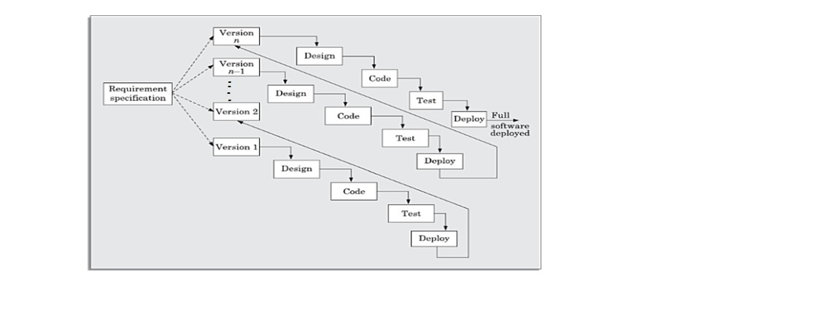

Figure1.1 [3] Incremental model

## **System development tools**

### **Hardware tools**

* Computer Desktop and laptop to develop our project means for documentation and implementation.
* Printer to print our project documents.
* Data storage like flash, CD, for backup.

### **Software tools**

* Editor like Notepad ++, sublime those are editors that we will use them to edit our source code.
* Browser like Google chrome, Mozilla Firefox, internet explorer, baidu spark, UC browsers and others are a client interface that display information to the users retrieved from the server and we will use them for testing or to run our projects.
* XAMP that collectively handle apache server, MySQL database software and Php.

### **Documentation tools**

* Microsoft word is free application software developed by the Microsoft Company and we will use it for preparing our project documentation.
* Microsoft power point is also open source application software developed by the Microsoft Company and we will use it for preparing our project presentation.
* Edrawmax and Microsoft Visio it an application software that helps us to draw different UML diagrams.

**Development tools**

* Php to develop back end of our program.
* Apache server since it runs in most of all web servers in the world.
* Database namely MySQL to store the organization permanent data’s.
* Java script frame works namely jQuery to validate different forms
* CSS framework namely bootstraps to make our user interface interactive.

## **Significant of the project**

* **For human resource office worker**
* The work load of the employees will be reduced.
* Easy to search employees profile or information.
* It will save time, man power and resource like papers.
* Easy to generate a report daily, weekly or monthly.
* It will be easy to post announcement and different notification.
* Higher speed of retrieval and processing of data.
* **For user (Applicant)**
* Users will get information and news from the office at anywhere and at any time if the user gets internet connection.
* It will save time, man power and resource like papers filling to be registered.
* Data will be secured for the users.

## **Feasibility of the project**

### **Technical feasibility**

At the implementation stage, we should use the different technology development tools. Such as Bootstrap for interactive user interface, PHP, HTML for front end, and MYSQL and apache server as back end which is the most recent and open source popular technologies to develop web based systems and to design the database and also that makes the system technically easier to be used by the user. As a result our system is technically feasible.

### **Operational feasibility**

Operational feasibility is a measure of how well our proposed system solves the existing manual system’s problem. After automating the system, it addresses basic problems of the organization, particularly employees information can be handled easily, which reduces the work load of staff, thus they feel good. Our project is design to solve different problems that are seen in the current implemented system like lack of interactive user interface, language problems since most implemented system are designed for peoples who know English language, and also the system will fit the system and users requirement with regard to development schedule, delivery date, and existing business process. Due to this our system is operationally feasible.

### **Economic feasibility**

This system is being passed through financial and cost examination. Due to this it has a good benefit categorized under tangible and intangible benefits. The tangible cost for this proposed system is only measured from the perspective of hardware and other expenses like transportation without including software development costs and some hardware materials like computer and internet connection which is fulfilled by the university.

The intangible cost includes the knowledge and time that we have spent on the development of the project. It is not counted in budget of the project because of it is measured in terms of grade that is why we say it is not estimated in terms of money. Therefore, from this point of view our system is economically feasible.

Table 2 Budget

|  |  |  |  |  |
| --- | --- | --- | --- | --- |
| **No** | **Name of item** | **Quantity** | **Single-price (birr)** | **Total cost**  **(birr)** |
| **1.** | CD-RW | 2 | 15.00 | 30 |
| **2.** | Flash-disk | 1(32GB) | 500.00 | 500 |
| **3.** | Paper | 1 Packet | 130.00 | 130 |
| **4.** | Printing papers | 100 pages | 3.00 | 300 |
| **5.** | Pen | 1 packet | 7.00 | 225 |
| **6.** | Mobile card | 10 | 25 | 250 |
| **7** | Laptop | 2 | 15,350 | 30,700 |
| **Total 32,235.00** | | | | |

### **Legal feasibility**

After our project is implemented it works in federal democratic republic of Ethiopian constitution as well as in woldia university rules and regulation. This means any employees who are not govern for the Ethiopian constitution as well as the universities rules and regulation should not be recruiting. And also any person who makes a crime like terrorism should not be recruiting. Due to this our project is legally feasible.

## **Work break down structure and schedule**

### **Work break down**

Table 3 Work break down

|  |  |
| --- | --- |
| Name of the student | Responsibility |
| Biruk Debebe | System designer, coder, tester |
| Daniel Tefera | Coder, system designer |
| Kasim Misganaw | System analyst, tester |
| Alelign Kebede | System analyst, coder |
| Ayalnesh Tsehaye | System analyst, tester |
| Habtam Dessie | System analyst, coder |

### **Schedule**

Anything that is done without plan and schedule is like the person that his eyes cannot see (blind). Therefore, the schedule is the eye of any project.

To finish our project in time we have planned it as follows.

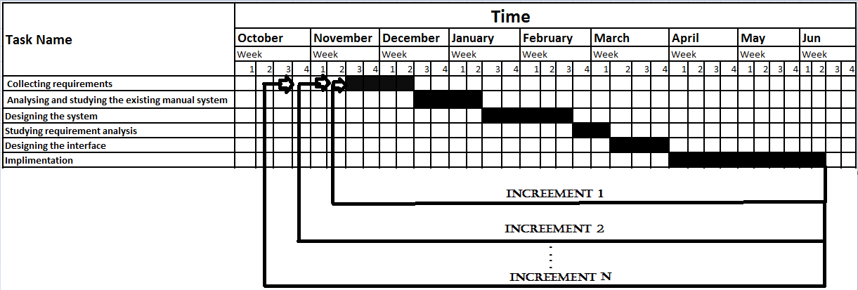

Figure 1.2 Schedule

# **CHAPTER TWO**

# **SYSTEM ANLYSIS AND MODELING**

## **Introduction to system analysis**

System analysis is conducted for the purpose of studying a system or its parts in order to identify its objectives. It is a problem solving technique that improves the system and ensures that all the components of the system work efficiently to accomplish their purpose. [9]

Studying the existing system brings about an important contribution to the entire development process. It is only after doing this phase that we can realize what is going wrong, what to change, what activity or practice to encourage, and what alternatives solution to propose.

### **Existing system**

The existing system in WLDU human resource management office performs their action manually. This leads to less user satisfaction and less interactive system. Since the existing system of the organization is manual system to perform many of their tasks such as data storage, data retrieval, attendance system and the recording system is manually done, due to this fact, the existing system is time consuming and bored. So, to have efficient and strong system it is better to change in to computerized system namely in our context web based system.

#### **Business Rules**

In every organizations or institutions there are rules and policy, which used to govern all activities in specified work flow, control the work flow, and perform in the work environment.

* **BR1**: To hire employee, the departments who needs employee should write an application letter for their vacant position to personnel department.
* **BR2**: when the vacant position is announced to external applicant on notice board, on mass media externally for consecutive five to ten workdays.
* **BR3**: To be employed, applicants should bring a clearance letter from previous employer.
* **BR4**: when the human resource hired the new employee to that of departments who needs an employee they must send a letter that has full documents about the new employee.
* **BR5**: Access information depends on the authority of the user.
* **BR6**: The employee must have full reason to apply leave application.
* **BR7**: If one wants to leave from WLDU before he/she fills the leave form, he/she must return all working material to respected department otherwise they will be rejected.
* **BR8**: Vacancies may be filled through recruitment, promotion transfer or redeployment based on the human resource plan.
* **BR9**: A vacant position shall be filled only by a person who meets the qualification required for the position and score higher than other.
* **BR10:** Any government institution based on its strategic plan shall prepare and implement short, medium, and long term human resource plan.
* **BR11:** Any allowance shall be paid only for the purpose of carrying out the functions of the civil service.
* **BR12:** Periodical salary increments to be made to civil servants shall be based on their performance evaluation results.
* **BR13:** Civil servants obtaining an evaluation result of satisfactory or above satisfactory shall be entitled to a salary increment to be made every two years.
* **BR14:** Any Government office, shall, at the end of every month, make payments of salary to civil servants or their legal representatives.
* **BR15:** To request leave any employee must live at least six month.

#### **Organization structure**

The organizational structure is the level of the management in WLDU as well as in the WLDU HR office that shows who is leader of the organization and who is under the specific leader or sub leader. The HRM office structure is shown below in figure 2.1 and for WLDU organizational structure see (appendix 1).

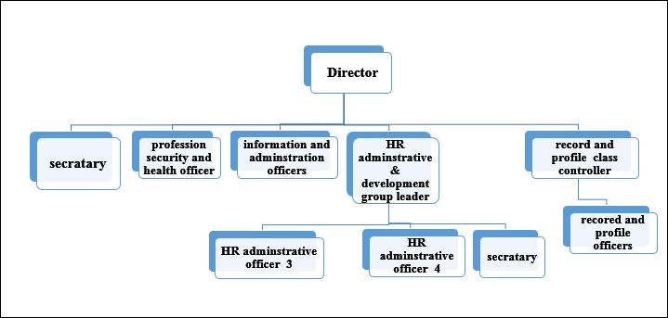

Figure 2.1 Organizational structure of HRMS office

#### **Activity of the existing system**

In the existing system there are many activities that are performed, among them recruiting employees for the WLDU asked by the college dean or the department is the main one. After recruiting someone in to the WLDU his or her detail profile filled by the employee in the paper after all, if it needs to update the employees profile the whole data should be erased and start in new form again. The employee also asks for promotion to transfer to the other university and also asks for leave or permission with a full detail reasons if the reason is view by the manager is complete the manager will approve the leave request. The employee or the record officer generates reports from papers that are registered before in a bored manner.

#### **Users of the existing system**

**Personnel officer –** Responsible for developing policies and procedures related to the staff employed by the organization.

**Top professional** – They are a person who communicates with the team leader and give clear instructions to the team members.

**Coordinators** – Ensuring the effective utilization of plans related to HR programs and services and administrating employee health and welfare plans.

**Team leader** – develop a strategy that the team will use to reach its goal and provide any training that the team members need.

**Director** – Annually review and makes recommendation to executive management for improvement of the organization policies, procedures and practices on personnel matter.

**Academic staffs** – like lecturers and assistants.

#### **Existing system workflow structure**

Work flow structure shows each and every step when performing one’s action. Here we covered two major work flow of the existing system namely employee promotion as shown below in Figure 2.2 and employee recruitment see (appendix 4)



Figure 2. 2 Work flow for employee promotion

#### **Forms used and reports generated**

In most organization there are forms that process the system to take place and reports generated from the system if manual from papers. So, here is the applicant competition form in figure 2.3 More forms are listed in the appendix (see from appendix 5 up to appendix 10) and reports see (appendix 2) that are used in WLDU human resource management office.

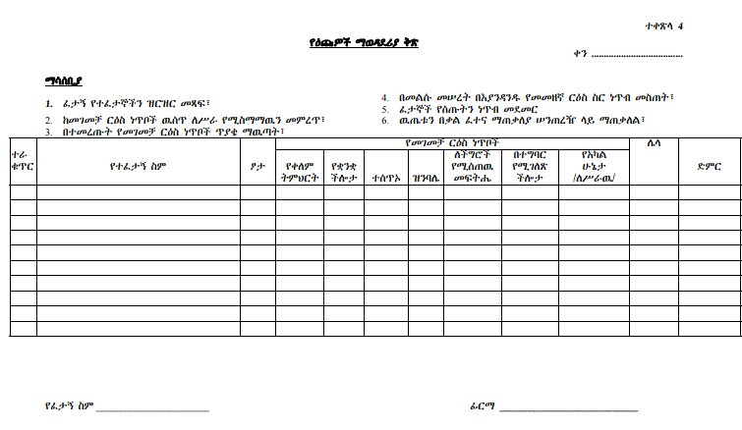

Figure 2.3[10] Applicants competition form

#### **Problem of the existing system**

As discussed above the currently the WLDU human resource management office uses manual system that is why it is suffer for many problems. Among the problems any data that is store in the office is not secured the data may be lost by theft or natural disaster, the other problems of the existing system is it is time consuming to perform any process whether to generate a reports or to fill employees profile and many other actions, the next one is for the applicants it is very difficult to access the vacancy posted by the WLDU HR office and also to apply they must come to the place of the HR office, the other is for the manager the current existing system is difficult to manage the employees day to day work flow, for the manager and the record officers to generate a report the current manual system takes much time and it is very bored, that manager also cannot get the applicant’s feedback easily, the department head or the college dean face difficulty is asking employees to be recruit in the department.

### **Proposed system**

This proposed system, which means a web based Human resource management system, would have attractive and user-friendly interface. And also this proposed system will change the manual system to computerized system and solve the existing problem. The proposed system provides employee details, detail general information about the employee along with educational background, certification, and skill and project details. It enhances the HR management in adding, viewing and updating employees’ details. No need of posting different announcement in the notice board, simply post the announcement and other important information on the web and everybody can see if internet connection is available. Also it enables the system user to use the system using Amharic and English language as the user option, Make employee registration and report generation, and facilitate the entire process online.

## **Functional Requirements**

Functional requirements are the type of requirements that a project must consider in its entire process. Operations those understand by the developer and stated as a way of automating the existing system. It is services that the system should provide to the user. This functional requirement defines what the systems do or the actual functionality of our system. The system provides the following functions.

* Announcement**: -** The system provides information of different announcement and makes the user informed like vacancies and others.
* Applicant registration: - The system registers applicants’ who wants to apply.
* Manage employee information**:** The system is able to search, register, update and delete the employee information when it is needed.
* Employee registration**: -** The system is able to recorded the new employed applicants and able to place to their respected position.
* Leave employee system**: -** The system allows to the employee able to fill in leave application form in the appropriate fields and the human resource manager allow leaving approval application based on the reason what the employee can be illustrated.
* Report generation**: -**The system is able to generate a report from existing data and filter by user criteria, generate report in the form of statistical data.
* Transfer: - This system allows the process of employee transfer from the WLDU to the other universities or organizations.

## **Non-Functional Requirements**

It describes user-visible aspects of the system that are not directly related with the functional behavior of the system. Non-functional requirements include quantitative constraints, such as response time (i.e., how fast the system reacts to user commands) or accuracy (i.e., how precise). The constraints are described below: -

* **Operability: -**Every operation of the system must be as simple as possible for the people to use simply. This by providing simple user interface using easy language so that users understand and operate the software easily
* **Usability: -**Since the system is easily accessed it is easily used everywhere in which computer and connection is available.
* **Maintainability: -** HRMS should be easy to extend. The code should be written in a way that it favors implementation of new functions. The SRS and Design document also enhances the upgrading and maintenance process in the future use.
* **Efficiency: -**The system can assume to run within a few second. To achieve the efficiency of this system, we use SQL database queries, this is efficient in query and processing and also we will use fastest algorithms.
* **Reliability: -**The information provided by HRMS is accurate and realistic.
* **Portability**: -This application is portable software which can operate on windows 7, windows 8 and above operating system platforms, and can run on any browser. This is because PHP is machine independent language.
* **Error handling: -**The system has error handling mechanisms that is, as errors occur it will not stop functioning rather provide error manages and should guide the user through what to do next.
* **Security: -**Since the system support user name and password to authentication and the system has different privilege to protect intruding and support MD5 encryption to prevent unwanted viewers.

## **Use case design**

A use case is a collection of interactions between external actors and a system. In UML, a use case is the specification of a sequence of actions, including variants, that a system (or entity) can perform, interacting with actors of the system.[8]

### **2.4.1 Actor identification and description**

The main actors of our system are: -

* Administrator – The user of the system that control and manages the user account including him/ herself.
* Record Officer – The user of the system that operates in related to employee information.
* HR Manager – The user of the system that controls the organization at the top.
* Employee – The user of the system who works in the WLDU.
* College Dean – The user of the system that leads some department or faculty.
* Applicant - The user of the system that applies in to the WLDU to recruit.

### **2.4.2 Use case identification**

* View vacancy
* View employee information
* View applicant information
* Register Applicant
* Login
* Apply
* Register Employee
* View Employee profile
* Update Employee profile
* Delete Employee profile
* Post Announcement
* Post Vacancy
* Request Leave
* Approve leave request
* Request Employee
* Approve employee request
* Give Comment
* View Comment
* Manage Account
* activate account
* deactivate account
* Create account
* Make announcement
* Prepare experience letter
* Prepare supportive letter
* Prepare employment letter
* Generate Report
* Annual report
* Semiannual report
* Three month report

### **2.4.3 Use case diagram**

Use case diagram represents user requirements gathered during requirement elicitation, contains use case, actors, system boundary and their relationships.

So, in our proposed system we have 6 actors, 23 use cases and between different use cases we used extend and include relationships. It will help us to identify which will perform which action.



Figure 2.4 Use case diagrams

### **2.4.4 Use Case description**

Use case description includes descriptions of the use case, preconditions, post conditions, flow of event, alternative flow of events, participating actors, quality requirements and whatever which is important in modeling the user goal.

Table 4 Use case description for log in

|  |  |  |
| --- | --- | --- |
| **Use case name** | Log in | |
| **Use case ID** | UC1 | |
| **Participating actor** | Administrator, Manager, Record officer, College dean, employee | |
| **Description** | The system user/participating actors will login to the system. | |
| **Flow of events** | **User action** | **System response** |
| 1. The system user clicks the log in link.  3. The system user will fill the valid username and password and finally press the submit button. | 2. The system will display the log in form.  4. The system will authenticate the filled username and password to the database.  5. If the username and password is match with the database, the system will allow the user to log in.  6. If not matched the system will display an error message. (A[6]:invalid data is filled) |
| **Entry condition** | The system user should have a valid username and password. | |
| **Exit condition** | The system user will logged in to the system. | |
| **Quality requirements** | The system response the log in page in less than 2 second.  The system will not allow with week and incorrect password. | |
| **Alternative flow of event** | A[6]:if invalid data is filled  1. The system will display “Log in failed” message.  2. The system will resume to step [2] | |

Table 5 Use case description for create account

|  |  |  |
| --- | --- | --- |
| **Use case name** | Create account | |
| **Use case ID** | UC2 | |
| **Participating actor** | Administrator | |
| **Description** | The administrator will create user accounts and give privileges for the user. | |
| **Flow of events** | **User action** | **System response** |
| 1. The administrator click the create account link.  3. The admin will fill the required information and finally press the submit button. | 2. The system will display the create account form.  4. The system will check the entire required field filled correctly if so, account will be created successfully. (A[4]:invalid data is filled) |
| **Entry condition** | The administrator should log in to the system. | |
| **Exit condition** | The administrator will create a user account successfully for the targeted user. | |
| **Quality requirements** | 1. The system response the create account page in 1 second.  2. The system will not allow incorrect fill of the form to create the account. | |
| **Alternative flow of event** | A[4]:if invalid data is filled  1. The system will display “please fill again” message.  2. The system will resume to step [2] | |

Table 6 Use case description for update account

|  |  |  |
| --- | --- | --- |
| **Use case name** | Activate/deactivate account | |
| **Use case ID** | UC3 | |
| **Participating actor** | Administrator | |
| **Description** | The administrator will activate or deactivate user accounts. | |
| **Flow of events** | **User action** | **System response** |
| 1. The administrator clicks on the activate/deactivate account link.  3. The admin will select particular action on the selected account he or she want to activate or deactivate. | 2. The system will display the list account with respect to activate or deactivate option.  4. The system will keep the changes if the administrator selects the action perfectly. A[6] |
| **Entry condition** | The administrator should log in to the system. | |
| **Exit condition** | The administrator will update a user account successfully for the targeted user. | |
| **Quality requirements** | 1. The system response to update account page in 1 second.  2. The system will not allow incorrect select to update the account. | |
| **Alternative flow of event** | A[6]:if invalid data is filled  1. The system will display “please fill again” message.  2. The system will resume to step [4] | |

Table 7 Use case description for post announcement

|  |  |  |
| --- | --- | --- |
| **Use case name** | Post announcement | |
| **Use case ID** | UC4 | |
| **Participating actor** | Manager | |
| **Description** | The manager posts different announcements to inform applicants and employees. | |
| **Flow of events** | **User action** | **System response** |
| 1. The manager clicks on the post announcement link.  3. The manager will fill the required information and finally press the post button. | 2. The system will display the post announcement form.  4. The system will check the entire required field filled correctly if so, the announcement will be posted successfully. (A[4]:invalid data is filled) |
| **Entry condition** | The manager should log in to the system. | |
| **Exit condition** | The manager will post announcements successfully for the targeted group. | |
| **Quality requirements** | 1. The system response the post announcement page in 1 second.  2. The system will not allow incorrect fill of the form to post announcement. | |
| **Alternative flow of event** | A[4]:if invalid data is filled  1. The system will display “please fill again” message.  2. The system will resume to step [2] | |

Table 8 Use case description for view vacancies

|  |  |  |
| --- | --- | --- |
| **Use case name** | View vacancies | |
| **Use case ID** | UC5 | |
| **Participating actor** | Applicant | |
| **Description** | The applicants will see what vacancies are posted before. | |
| **Flow of events** | **User action** | **System response** |
| 1. The applicant will browse the system and press the view vacancy link. | 2. The system will display the posted vacancies. |
| **Entry condition** | The applicant should browse the system. | |
| **Exit condition** | The applicant will view the vacancies posted before. | |
| **Quality requirements** | 1. The system display the posted vacancies in 1 second. | |
| **Alternative flow of event** | No | |

Table 9 Use case description for view recruiting information

|  |  |  |
| --- | --- | --- |
| **Use case came** | View employee information | |
| **Use case ID** | UC7 | |
| **Participating actor** | Record Officer | |
| **Description** | The record officer can see employees information | |
| **Flow of events** | **User action** | **System response** |
| 1. The user must browse the system and log in to the system.  3. The record officer will click on the view employee information. | 2. The system will display the user’s home page.  4. The system will display all employee’s information. |
| **Entry condition** | The record officer should log in to the system. | |
| **Exit condition** | The record officer can see employee’s status successfully. | |
| **Quality requirements** | 1. The system response the employee’s information in 1 second. | |
| **Alternative flow of event** | No | |

Table 10 Use case description for request leave

|  |  |  |
| --- | --- | --- |
| **Use case name** | Request leave | |
| **Use case ID** | UC9 | |
| **Participating actor** | Employee | |
| **Description** | The employee’s fill the leave request application form if they wants to leave the work by any reasons. | |
| **Flow of events** | **User action** | **System response** |
| 1. The user will hit the request leave link.  3. The user will fill the required information and finally press the submit button. | 2. The system will display the leave application form.  4. The system will check the entire required field filled correctly if so, the user can send leave request. (A[4]:invalid data is filled) |
| **Entry condition** | The employee should log in to the system. | |
| **Exit condition** | The leave request will sent successfully. | |
| **Quality requirements** | 1. The system response leaves application form in 1 second.  2. The system will not allow incorrect fill of the form to post announcement. | |
| **Alternative flow of event** | A[4]:if invalid data is filled  1. The system will display “please fill again” message.  2. The system will resume to step [2] | |

Table 11 Use case description for generate report

|  |  |  |
| --- | --- | --- |
| **Use case came** | Generate report | |
| **Use case ID** | UC9 | |
| **Participating actor** | Manager | |
| **Description** | The system will generate a report based on the information stored in the database. | |
| **Flow of events** | **User action** | **System response** |
| 1. The user will click generate report menu.  3. The user will select the report type whether it is three month report, semi-annual report or annual report.  5. The user will select the report type that he or she wants to see.  6. The manager can print the report if necessary. | 2. The system will display the report list.  4. The system will display the type of report that can be generated by the system like registered employee list, employees who ask for leave, and other types will be selected by the manager.  5. The system will display the report successfully if there is requested data in the database. (A[5]:no data in the database) |
| **Entry condition** | The manager should log in to the system. | |
| **Exit condition** | The report will be generated successfully | |
| **Quality requirements** | 1. The system response the report list and the report will be generated in 1 second. | |
| **Alternative flow of event** | A[5]:if no data is available in the database  1. The system will display “no data is there” message. | |

Table 12 Use case description for view report

|  |  |  |
| --- | --- | --- |
| **Use case name** | View reports | |
| **Use case ID** | UC10 | |
| **Participating actor** | Manager | |
| **Description** | The manager can see reports that are generated from the system. | |
| **Flow of events** | **User action** | **System response** |
| 1. The system user will browse the system and press the view report link.  2. The system user will see reports. | 2. The system will display the report information. |
| **Entry condition** | The system user should browse the system and log in to the system. | |
| **Exit condition** | The system user will get reports from the system. | |
| **Quality requirements** | 1. The system display the reports in 1 second. | |
| **Alternative flow of event** | No | |

Table 13 Use case description for send feedback

|  |  |  |
| --- | --- | --- |
| **Use case name** | Give feedback | |
| **Use case ID** | UC12 | |
| **Participating actor** | Applicant | |
| **Description** | The applicant will give a feedback about everything that relate to the organization. | |
| **Flow of events** | **User action** | **System response** |
| 1 The applicants will click on feedback tab from the main window.  3 Applicants will fill the feedback form with his/her correct contact bases. | 2 The system will display feedback form.  4 The system will verify and display Success message. (A[4]:invalid data is filled) |
| **Entry condition** | Applicants must have contact bases like email, face book, or twitter account and should enter to the website. | |
| **Exit condition** | The feedback will be delivered to the manager | |
| **Quality requirements** | The system takes less than 1 second to send 100mb feedbacks. | |
| **Alternative flow of event** | A[4]:if invalid data is filled  1. The system will display “please fill again” message.  2. The system will resume to step [2] | |

Table 14 Use case description for update employee information

|  |  |  |
| --- | --- | --- |
| **Use case name** | update employee information | |
| **Use case ID** | UC12 | |
| **Participating actor** | Record officer | |
| **Description** | The record officer will update employee information that are recorded before. | |
| **Flow of events** | **User action** | **System response** |
| The record officer will click the update employee information link.  3. The record officer will select particular employee he or she want to update.  5. The record officer will fill information that he or she wants to update then press the update button. | 2. The system will display the list of employee’s that are recorded before.  4. The system will display the employee information with appropriate values.  6. The system will check the update information is filled correctly, if so, account will be updated successfully.  (A[6]:invalid data is filled) |
| **Entry condition** | The record officer should log in to the system. | |
| **Exit condition** | The record officer will update employee information successfully. | |
| **Quality requirements** | 1. The system response to update employee page in 1 second.  2. The system will not allow incorrect fill of the form to update the employee information. | |
| **Alternative flow of event** | A[6]:if invalid data is filled  1. The system will display “please fill again” message.  2. The system will resume to step [4] | |

Table 15 Use case description for register employee

|  |  |  |
| --- | --- | --- |
| **Use case name** | Register employee | |
| **Use case ID** | UC13 | |
| **Participating actor** | Record officer | |
| **Description** | Record officer will register employees who are recruiting in the WLDU human resource office. | |
| **Flow of events** | **User action** | **System response** |
| 1. The Record officer will click the register employee link.  5. The record officer will fill employee’s information required and click the submit button. | 2. The system will display employee registration form.  6. The system will check whether the data is filled correctly or not, if so the user registered successfully. (A[6]:invalid data is filled) |
| **Entry condition** | The record officer should log in to the system. | |
| **Exit condition** | The employee will register successfully. | |
| **Quality requirements** | 1. The system response the registration form in 1 second.  2. The system will not allow incorrect fill of the form to post announcement. | |
| **Alternative flow of event** | A[6]:if invalid data is filled  1. The system will display “incorrect fill, please fill again” message.  2. The system will resume to step [2] | |

Table 16 Use case description for approve employee request

|  |  |  |
| --- | --- | --- |
| **Use case name** | Approve employee request | |
| **Use case ID** | UC14 | |
| **Participating actor** | Manager | |
| **Description** | The manager will approve employee request’s that are sent from the college dean/department. | |
| **Flow of events** | **User action** | **System response** |
| 1. The manager will click the approve employee request link.  3. The manager will check the specification and the budget and then press the approve button. | 2. The system will display employee requests that are sent from the college dean/department.  4. The system will send a notification to the department/college dean. |
| **Entry condition** | The manager should log in to the system. | |
| **Exit condition** | The employee requests that are sent from the department/college dean will approved successfully. | |
| **Quality requirements** | 1. The system will send a notification in a few second.  2. The system will display requests that are sent from the department/college dean in 1 second. | |
| **Alternative flow of event** | No | |

Table 17 Use case description for approve leave request

|  |  |  |
| --- | --- | --- |
| **Use case name** | Approve leave request | |
| **Use case ID** | UC15 | |
| **Participating actor** | Manager | |
| **Description** | The manager will approve leave request’s that are sent from the employee’s. | |
| **Flow of events** | **User action** | **System response** |
| 1. The manager will click the approve leave request link.  3. The manager will see the reason and work challenge and then press the approve button. | 2. The system will display leave requests that are sent from the employee’s.  4. The system will send a notification to the employee. |
| **Entry condition** | The manager should log in to the system. | |
| **Exit condition** | The leave requests that are sent from the employee’s will approve successfully. | |
| **Quality requirements** | 1. The system will send a notification in a few second.  2. The system will display requests that are sent from the department/college dean in 1 second. | |
| **Alternative flow of event** | No | |

Table 18 Use case description for view feedback

|  |  |  |
| --- | --- | --- |
| **Use case name** | View feedback | |
| **Use case ID** | UC16 | |
| **Participating actor** | Manager | |
| **Description** | The manager will view the comments that are sent from the applicants. | |
| **Flow of events** | **User action** | **System response** |
| 1. The manager clicks the view comment link. | 2. The system will display the comments that are sent from the applicants and users.  3. If no comments are there the system will display no comments messages. |
| **Entry condition** | The manager should log in to the system. | |
| **Exit condition** | The manager will get comments from the system or no comments messages. | |
| **Quality requirements** | The system displays the comment in a few second. | |

Table 19 Use case description for view employee information

|  |  |  |
| --- | --- | --- |
| **Use case name** | View employee’s information | |
| **Use case ID** | UC17 | |
| **Participating actor** | Record officer | |
| **Description** | The Record officer can see employee’s information that are recorded before. | |
| **Flow of events** | **User action** | **System response** |
| 1. The Record officer will click on the view employee information. | 2. The system will display employee’s information. |
| **Entry condition** | The Record officer should log in to the system. | |
| **Exit condition** | The Record officer can see employee’s information successfully. | |
| **Quality requirements** | 1. The system response the employee’s information in a few second. | |
| **Alternative flow of event** | No | |

Table 20 Use case description for employee request

|  |  |  |
| --- | --- | --- |
| **Use case name** | Employee request | |
| **Use case ID** | UC18 | |
| **Participating actor** | College dean / department | |
| **Description** | The department/college dean fill the employee request application form if they wants additional employee’s for their staff. | |
| **Flow of events** | **User action** | **System response** |
| 1. The college dean or the department will hit the employee request link.  3. The college dean or the department will fill the required information and finally press the submit button. | 2. The system will display the employee request application form.  4. The system will check all the required field filled correctly if so, the user can send leave request. (A[4]:invalid data is filled) |
| **Entry condition** | The college dean or the department should log in to the system. | |
| **Exit condition** | The employee request will sent to the WLDU human resource office manager successfully. | |
| **Quality Requirements** | 1. The system response employee request application form in 1 second.  2. The system will not allow incorrect fill of the form to post announcement. | |
| **Alternative flow of event** | A[4]:if invalid data is filled  1. The system will display “please fill again” message.  2. The system will resume to step [2] | |

Table 21 Use case description for change password

|  |  |  |
| --- | --- | --- |
| **Use case name** | Change password | |
| **Use case ID** | UC19 | |
| **Actors** | Administrator, college dean/department, manager, record officer and employee | |
| **Description** | It allows the system users to change their passwords. | |
| **Flow of events** | **User action** | **System response** |
| 1. User clicks the change password button  3. User fill his/her old password and new password and final he or she confirm the new password. | 2. The System displays change password form.  4. System checks the entered password and display success message. (A [4]: If invalid data is filled). |
| **Entry condition** | The system user must log in to the system. | |
| **Exit condition** | The system users change their password successfully. | |
| **Quality Requirements** | 1. The system response change password form in 1 second.  2. The system will not allow incorrect fill of the form to change password. | |
| **Alternative flow of event** | A[4]:if invalid data is filled  1. The system will display “please fill again” message.  2. The system will resume to step [2]. | |

Table 22 Use case description for post vacancy

|  |  |  |
| --- | --- | --- |
| **Use case name** | Post vacancy | |
| **Use case ID** | UC20 | |
| **Participating actor** | Manager | |
| **Description** | The manager posts different vacancies to the public on this system. | |
| **Flow of events** | **User action** | **System response** |
| 1. The manager clicks the post vacancy link.  3. The manager will fill the required information and finally press the post button. | 2. The system will display the post vacancy form.  4. The system will check the entire required field filled correctly if so, the vacancy will be posted successfully. (A[4]:invalid data is filled) |
| **Entry condition** | The manager should log in to the system. | |
| **Exit condition** | The manager will post vacancies successfully. | |
| **Quality requirements** | 1. The system response the post vacancy page in 1 second.  2. The system will not allow incorrect fill of the form to post vacancies. | |
| **Alternative flow of event** | A[4]:if invalid data is filled  1. The system will display “please fill again” message.  2. The system will resume to step [2] | |

Table 23 Use case description for view announcement

|  |  |  |
| --- | --- | --- |
| **Use case name** | View announcement | |
| **Use case ID** | UC21 | |
| **Participating actor** | Employee, College dean | |
| **Description** | The employee/college dean will see what announcements are posted before. | |
| **Flow of events** | **User action** | **System response** |
| 1. The employee/college dean will browse the system and press the view announcement link. | 2. The system will display the posted announcement. |
| **Entry condition** | The employee’s/college dean should browse the system and log in to the system. | |
| **Exit condition** | The employee and the college dean will view the announcement posted before. | |
| **Quality requirements** | 1. The system displays the posted announcement in 1 second. | |
| **Alternative flow of event** | No | |

Table 24 Use case description for help

|  |  |  |
| --- | --- | --- |
| **Use case name** | Help | |
| **Use case ID** | UC22 | |
| **Participating actor** | Employee, manager, record officer, college dean/department, applicant, administrator. | |
| **Description** | The system user will get text help that helps how they can use the system. | |
| **Flow of events** | **User action** | **System response** |
| 1. The system user will browse the system and press the help link.  2. The system user will see helps from the system. | 2. The system will display the help. |
| **Entry condition** | The system user should browse the system and log in to the system if he / she is not the applicant. | |
| **Exit condition** | The system user will get the help that is very help full to use the system effectively and efficiently. | |
| **Quality requirements** | 1. The system displays the help in 1 second. | |
| **Alternative flow of event** | No | |

Table 25 Use case description for log out

|  |  |  |
| --- | --- | --- |
| **Use case name** | Log out | |
| **Use case ID** | UC23 | |
| **Participating actor** | Admin, Manager, Record Officer, College dean/department head | |
| **Description** | After the user finish his work he or she will log out. | |
| **Flow of events** | **User action** | **System response** |
| 1 The user will click on log out tab from the main window.  3 The user will click either of the choice yes or no. | 2 The system will display a choice by asking a question is you sure do you want to log out?  4 If yes is clicked the system will out of the user’s page or the system will redirected to the log in page, if no is clicked the system will back to the user’s page. |
| **Entry condition** | The user should close histories and any pages that opened during his or her work. | |
| **Exit condition** | The user will be out of the administrator pages | |
| **Quality requirements** | The system will be log out in 1 second. | |

Table 26 Use case description for apply for promotion

|  |  |  |
| --- | --- | --- |
| **Use case name** | Apply for transfer | |
| **Use case ID** | UC23 | |
| **Actor** | Employee | |
| **Description** | It allows the employee to apply for transfer. | |
| **Flow of events** | **User action** | **System response** |
| 1. Employee clicks the apply for transfer.  3. Employee fills required field to apply for transfer | 2. The System displays apply for transfer form.  4. System checks the entered data and display success message. (A [4]: If invalid data is filled). |
| **Entry condition** | The employee must log in to the system. | |
| **Exit condition** | The employee will apply promotion successfully. | |
| **Quality requirements** | 1. The system response displays apply for promotion form in 1 second.  2. The system will not allow incorrect fill of the form to change password. | |
| **Alternative flow of event** | A[4]:if invalid data is filled  1. The system will display “please fill again” message.  2. The system will resume to step [2] | |

## **Sequence diagrams**

Sequence diagrams show a succession of interactions between classes or object instances over time. For instance, in our context if someone who wants to log in must pass through that succession of interactions. Below those basic sequence diagrams of our proposed system is shown in the following figures from Figure 2.11 to Figure 2.20



Figure2.5 Sequence diagram for log in



Figure 2.6 Sequence diagram for create account



Figure 2.7 Sequence diagram for post announcement



Figure 2.8 Sequence diagram for post vacancy



Figure 2.9 Sequence diagram for send feedback



Figure 2.10 Sequence diagram for view announcement



Figure 2.11 Sequence diagram for view employee information



Figure 2.12 Sequence diagram for view feedback



Figure 2.13 Sequence diagram for view vacancy



Figure 2.14 Sequence diagram for employee registration

## **Activity diagram**

An activity diagram describes the behavior of a system in terms of activities. Activities are modeling elements that represent the execution of a set of operations. The execution of an activity can be triggered by the completion of other activities, by the availability of objects, or by external events. Activity diagrams are similar to flowchart diagrams in that they can be used to represent control flow (i.e., the order in which operations occur) and data flow (i.e., the objects that are exchanged among operations). [8]



Figure 2.15 Activity diagram for log in



Figure 2.16 Activity diagram for view feedback



Figure 2.17 Activity diagram for view report



Figure 2.18 Activity diagram for change password



Figure 2.19 Activity diagram for register applicant

## **Class diagram**

Our proposed system’s class diagram has 14 classes each classes have their own attributes and methods. Each class have a relation with at least one class. The User class is a parent or extended class that shares its property attributes and methods to the child or the extending classes.



Figure 2.20 Class diagram

## **Data structural model**

Data models are the conceptual models that describe the structures of databases. Structure of a database is defined by the data types, the constraints and the relationships for the description or storage of data. Following are the most often used data models:[9]

### **Entity – relation(ER) diagram**

The ER model describes data as entities, relationship, and attributes. It was developed to facilitate database design by allowing the specification of an enterprise schema, which represents the overall logical structure of a database. An entity-relationship model (ERM) is a model that provides a high-level description of a conceptual data model. Data modeling provides a graphical notation for representing such data models in the form of entity-relationship diagrams (ERD).[9]

In our proposed system we have 11 entities and each entity have their own attributes. Each entity has a relationship with at least one entity. The attributes are represented based on their nature for example the age attribute which is the manager entity is represented with broken line ellipse. Primary key should be underlined like college id which is the attributes of the college dean entity. Multivalued attributes will be encircled with double lines like email which is the attributes of the employee entity.

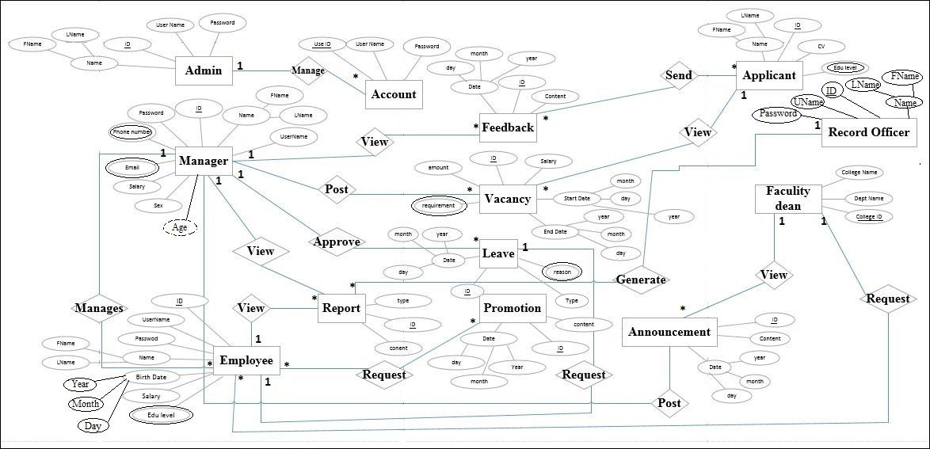

Figure 2.21 ER diagram

## **Pseudo code for login**

Procedure

Method name: **login ()**

**Begin**

Get username;

Get password;

Roll;

**IF** (Username==Entered Username && password==Entered password && Roll==selected roll)

THEN

Login successful

**Else**

Login failed you have entered incorrect username and password

**End**

## **Pseudo code for create account**

Procedure

Method name: **register ()**

**Begin**

Get full name;

Get ID_No;

Get password;

(Check input validation)

**IF** (input is valid)

{

Register account to database

Show success message

**} ELSE**

Display error message and ask correct user information

**END**

# **CHAPTER THREE**

# **DESIGN**

## **3.1 Purpose and goal of design**

Design goal describes the qualities of the system that developers should optimize such goals normally derived from the non-functional requirements of the system which is stated in chapter two of this document. They describe the qualities of the system. The goal considers the following criteria’s. These are

* Performance criteria
* Maintenance criteria
* End user criteria
* Security requirements

**Performance criteria**

The programming language that we use for this system should have a fast response time (real time) with maximum throughput. Furthermore, the system should not be taking up too much space in memory. The user gets fast response time over throughput and hence the system should try to be more interactive. The system should be more reliable in order to satisfy the constraint than fast response time. As generalized our team member measure the performance of the system in the following main concepts.

* **Response time –** quickly reacts to the user. Response requests to the user with in two second.
* **Throughput –** The system can accomplish high amount of output with in specified amount of time.
* **Availability –** The system is always operational and accessible for the users when the connection is available.
* **Accuracy –** The system will display expected output.

**Maintenance criteria**

The system will easily modifiable like registering new employees, activating and deactivating users from the database. It is readable since the source code of the system is restricted to be understood by the programmer of the system or a person who has a great knowledge on web developing languages like PHP, HTML, CSS, and JS

**End user criteria**

**Usability –** usability is the extent to which a product can used by specified user to achieve specified goal with effectiveness, efficiency, and satisfaction in a specified context of use. From the end user’s perspective the system should be designed in such a way that it is easy to learn and use, efficient and having few errors if any.

**Security requirements**

**Security for the user of the system**

* The system provides privileges to administrator to create account to log in to the system.
* No one can view the site of other user page.
* The system will have another security keeping mechanism which is called session and java script which can help user to log in to the system and cannot back in to the securable pages.
* Only a person who has a privilege to the system can log on by providing user name and password.
* The password will encrypted by MD5 encryption mechanism.
* The login link is visible in the woldia university only to protects from brute force attack; a person who wants to access the protected page from outside and to attack the system information. Because the system had two parts; the one is applicant’s part which is deployed on the woldia university server but, have the domain name that can accessed outside the university and the other part which is more sensitive part should be deployed in the woldia university server which have the domain name accessed inside the university only.

## **3.2 Current Software architecture**

Currently the Woldia University have no system for the human resource office they are simply perform all their tasks manually so, the current manual system has not software architecture.

## **3.3 Proposed software architecture**

The architecture that we have used for the system is a 3 tier which is a web based application in which the presentation tier, a business or data access tier, and a data tier are developed and maintained as independent modules on separate platforms. Three layers in the three tier architecture are as follows:

* Client layer
* Middle layer
* Data layer

**Client layer**

The client tier is the applications of user interface containing data entry forms and client side applications. For example, registrations form for new users which contain text box, labels, and buttons etc. So, it displays data to the user and users interact directly with the application through user interface. The client tier interacts with the web/application server to make requests and to retrieve data from the database. It then displays to the user the data retrieved from the server.

**Middle layer**

The middle tier (web/application server) implements the business logic, controller logic and presentation logic to control the interaction between the application’s clients and data. The controller logic processes client requests such as requests to view comments, to deactivate users or to retrieve data from the database.

**Data layer**

The system has data access layer which requires SQL skill in the form of DDL and DML contains methods to connect with database and to perform insert, update, delete, get data from database based on users input data.



Figure3.1 Software Architecture diagram

### **3.3.1 Sub system decomposition**

To reduce the complexity of the system, we have decomposed the system into six parts based up on the functionality, where each those subsystems have their own subsystems.

**Sub system for administrator**

* Log in
* Create account
* Update account
* View help
* Change password
* Log out
* Activate and deactivate user’s account

**Sub system for manager**

* Log in
* Approve/reject leave request
* Approve/reject employee request
* Approve/reject transfer request
* View feedbacks
* Post announcement
* View report
* View employee information
* View applicant information
* View help
* Change password
* Post vacancy
* Log out

**Sub system for record officer**

* Log in
* Change password
* Register employee profiles
* Update employee profiles
* Search employee profiles
* Delete employee profiles
* View help
* Log out

**Sub system for applicants**

* Send feedback
* View vacancy
* Apply
* View help

**Sub system for employee**

* Log in
* Request leave
* Apply for transfer
* View announcement
* View help
* Change password
* Log out

**Sub system for department head or college dean**

* Log in
* Change password
* View announcement
* View help
* Request employee
* Log out

### **3.3.2 Component diagram**

A component diagram describes the organization of the physical components in a system. Components are modeled as rectangles with two smaller rectangles jutting out from the left hand side. Components have dependencies on the interface of other components.

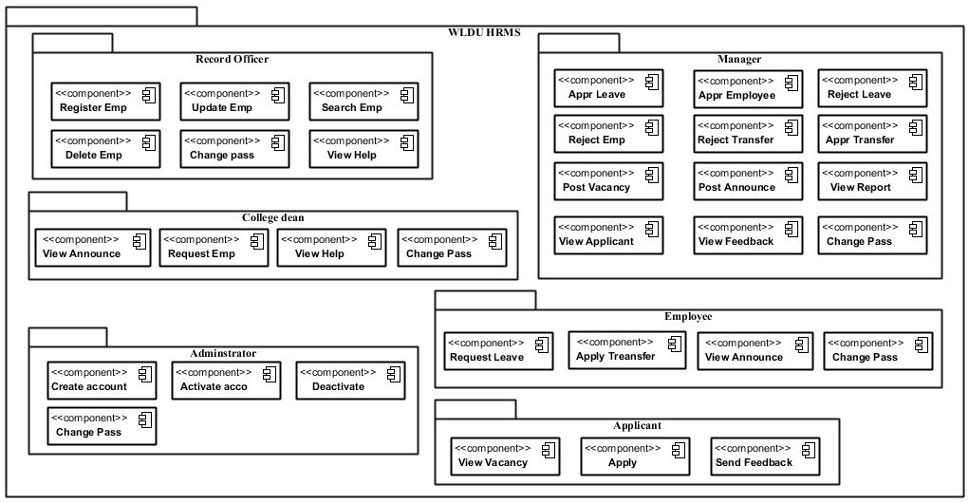

Figure 3.2 Sub system decomposition

### **3.3.3 Deployment diagram**

A Deployment Modeling shows the configuration of run-time processing elements and the software components, processes, and objects. And also it shows the physical configuration of software and hardware [2].Figure 3.2 represents deployment diagram below.

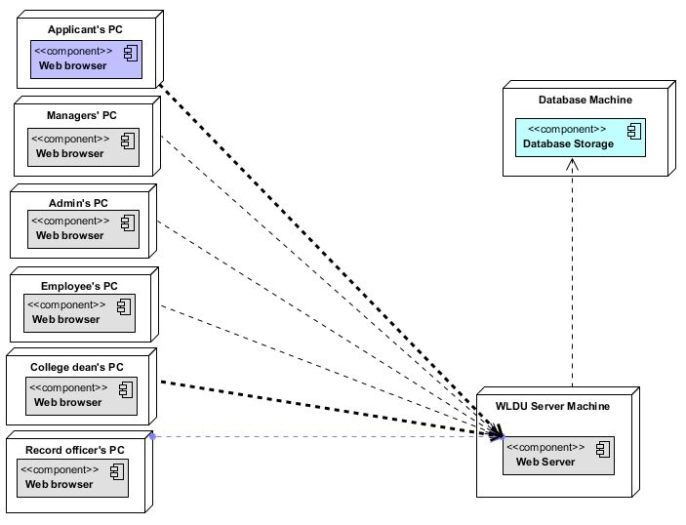

Figure3.3 Deployment diagram

### **3.4.4 Persistence modeling for object oriented database**

Persistent data management deals with how the persistent data (database) are stored and managed and it outlives a single execution of the system [3]. At that time the timetable produced are persistent data and hence stored on a database system. This allows all the programs that operate on the WLDU HRMS data to do consistently. Moreover, storing data in a database enables the system to perform complex queries on a large data set. The administrator adds, view or deactivate employee and view employee information or comments. The database retains, applicant’s employees, record officer’s, college deans and administrator data. Each of these items was in separate table. Database use a primary key - in the case of the employee table, emp_id is the primary key to each employee. So, we have selected object-oriented database management system for persistent data management of the project. Generally, the objective of the database design is to store persistent information for later use. As such the database is to maintain employee’s information, manager, record officer, college dean, and applicant and administrator information of the system for security purpose. The persistence storage tables used by the system are: users table, announcement table, applicant table, educational_info table, emergency_contact table, employee_request table, family_situation table, feedback table, guaranter_contact table, leave table, personal_info table, reset password, residential_address table, transfer table, and cavancytable. These used to support the data storage of record management system application. In general, we have wldu_hrms as database package which consist 15 tables under it that store applicant, employee and other data.

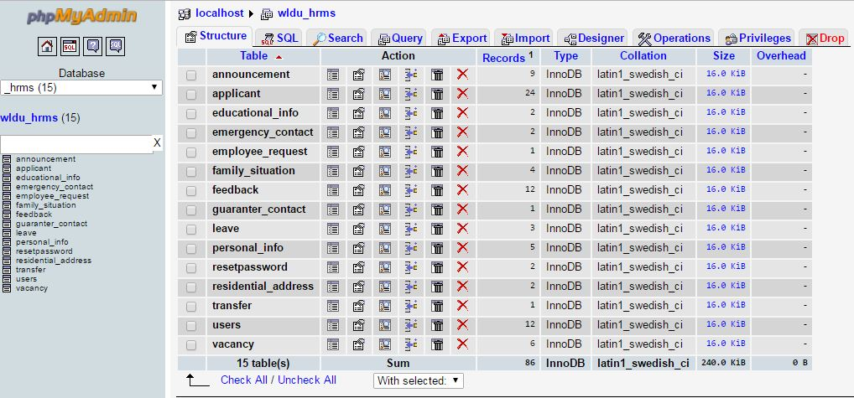

Figure 3. 4 The structure of wldu_hrms database diagram

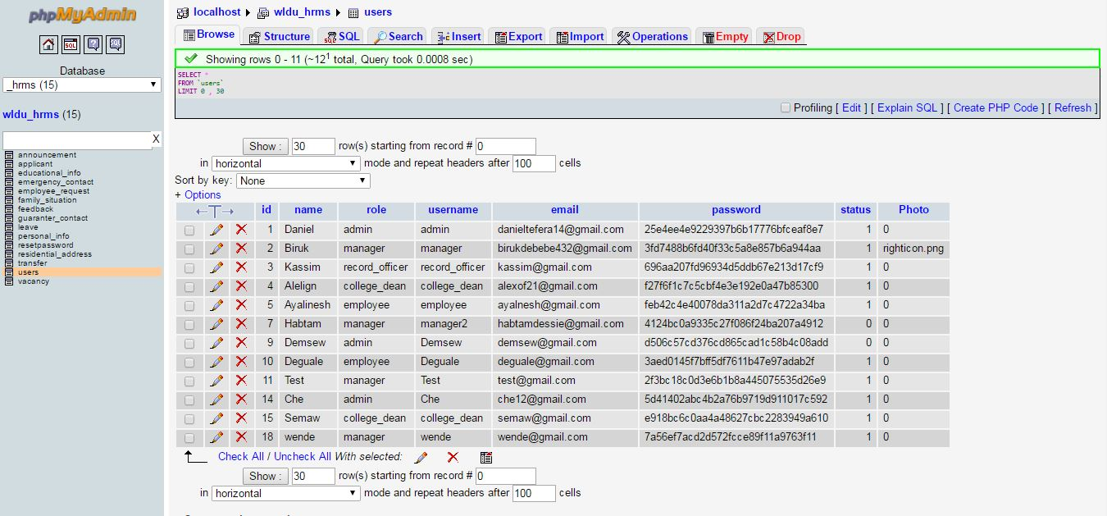

Figure 3.5 The structure of users table diagram

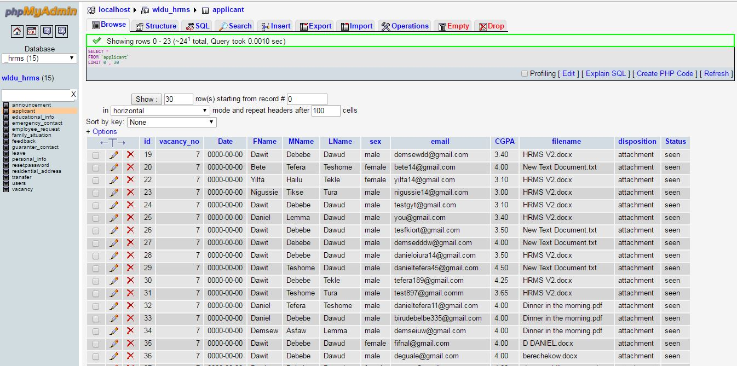

Figure 3. 6 The structure of applicant table diagram

### **3.4.5 Access control and security**

Access control is way of limiting access to a system or to physical or virtual resources. In computing, access control is a process by which users are granted access and certain privileges to systems, resources or information.

Table 27Access control and security

|  |  |  |  |  |  |  |
| --- | --- | --- | --- | --- | --- | --- |
| **Function** | **Actors** | | | | | |
| **Administrator** | **Manager** | **Record officer** | **Applicants** | **College dean/department head** | **Employee** |
| Log in | Yes | Yes | Yes | No | Yes | Yes |
| Create account | Yes | No | No | No | No | No |
| Update account | Yes | No | No | No | No | No |
| View help | Yes | Yes | Yes | Yes | Yes | Yes |
| Change password | Yes | Yes | Yes | Yes | Yes | Yes |
| View feedback | No | Yes | No | No | No | No |
| Post announcement | No | Yes | No | No | No | No |
| View report | No | Yes |  | No | No | No |
| View employee information | No | Yes |  | No | No | Yes |
| Register employee | No | Yes |  | No | No | No |
| Post vacancy | No | Yes |  | No | No | No |
| Update employee information | No | Yes | Yes | No | No | No |
| Generate report | No | No | Yes | No | No | Yes |
| Request leave | No | No |  | No | No | Yes |
| Apply for promotion | No | No | No | No | No | Yes |
| View announcement | No | No | No | No | Yes | Yes |
| Request employee | No | No | No | No | Yes | No |
| Send feedback | No | No | No | Yes | No | No |
| View vacancy | No | No | No | Yes |  | No |
| Apply | No | No | No | Yes | No | No |

### **3.4.6 Boundary condition and exception handling**

**Client side**

* Internet connection should be available on the client side.
* Web browser is demanding to connect with the web server of the system.
* The user except the applicant should be legitimate and having an account provided by the system administrator.
* It should give the URL (Uniform Resource Locator) address of the web site.
* The user communicates the different hyperlinks/pages using the homepage.
* The Applicant can get different service from viewing the available vacancies up to applying to recruit.

**Server side**

* The system administrator manages the user account using his/her preferred privileges.
* It automatically saves the changes when manages users account.

**Exception handling**

* The system displays messages if it is tried to access using wrong/invalid account by checking against the account table.
* If the employee is blocked, he cannot login to the system.
* The applicant should have an email address and other attributes should filled correctly to apply otherwise it will display error message.
* Any forms in the system should be filling out with a valid value if it is not the system will display error message.

## **3.5. User-Interface Design**

**Interface of WLDU HRMS user login page**

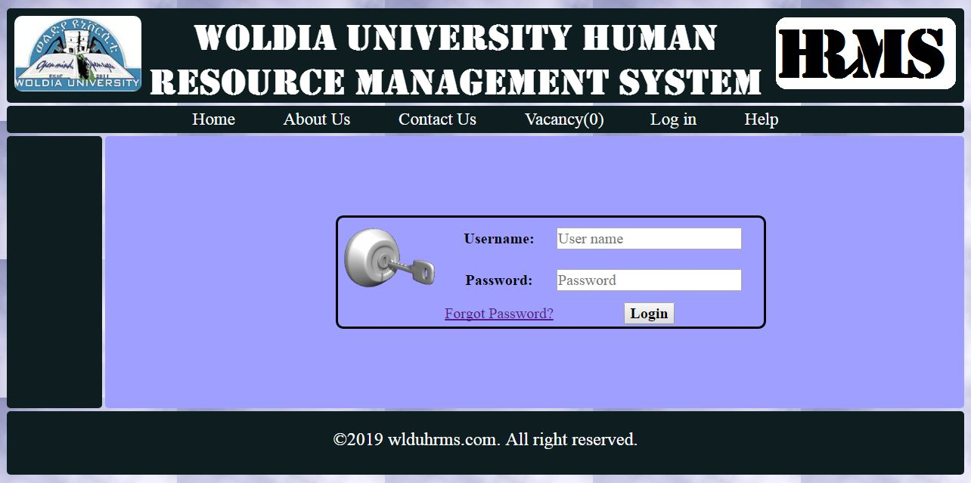

Figure 3.7 Log in page interface

**Interface of WLDU HRMS admin activate and deactivate user page**

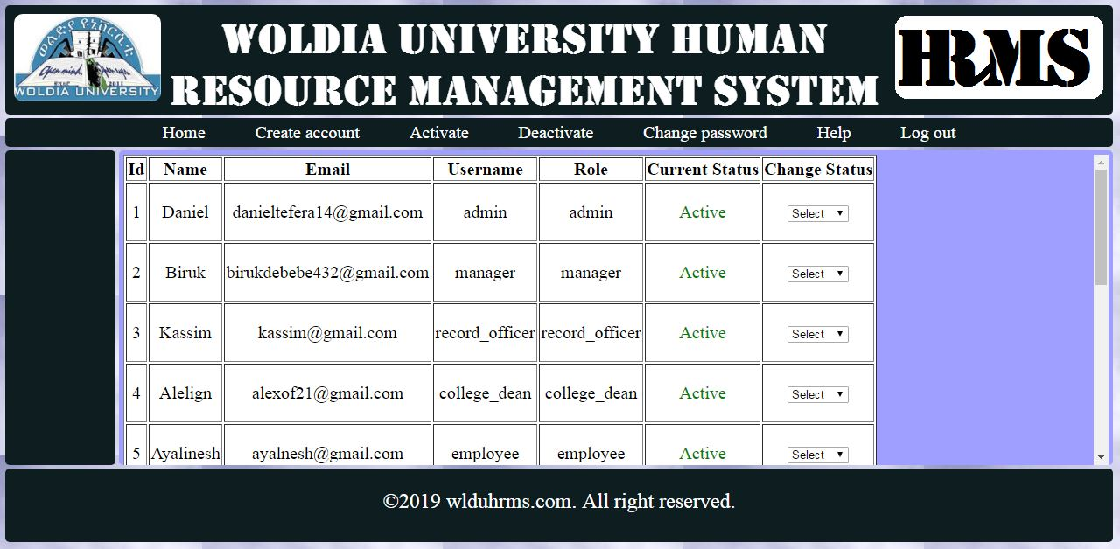

Figure 3.8 account activate deactivate page interface

**Interface of WLDU HRMS applicant apply page**

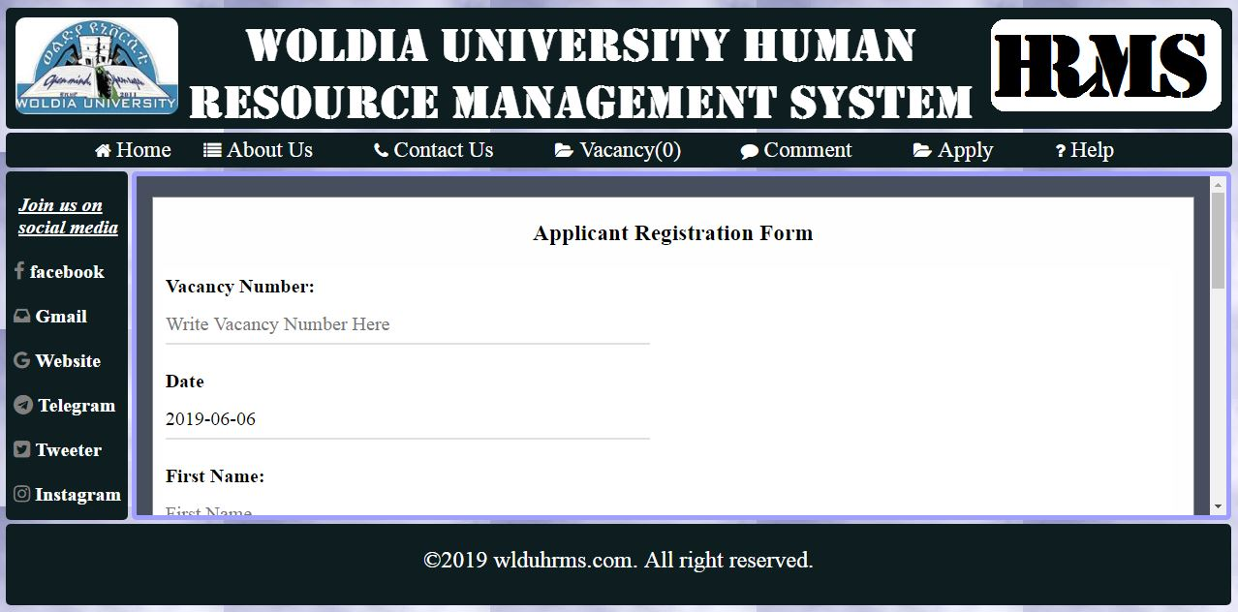

Figure 3.9 applicant apply page interface

**Interface of WLDU HRMS applicant home page**

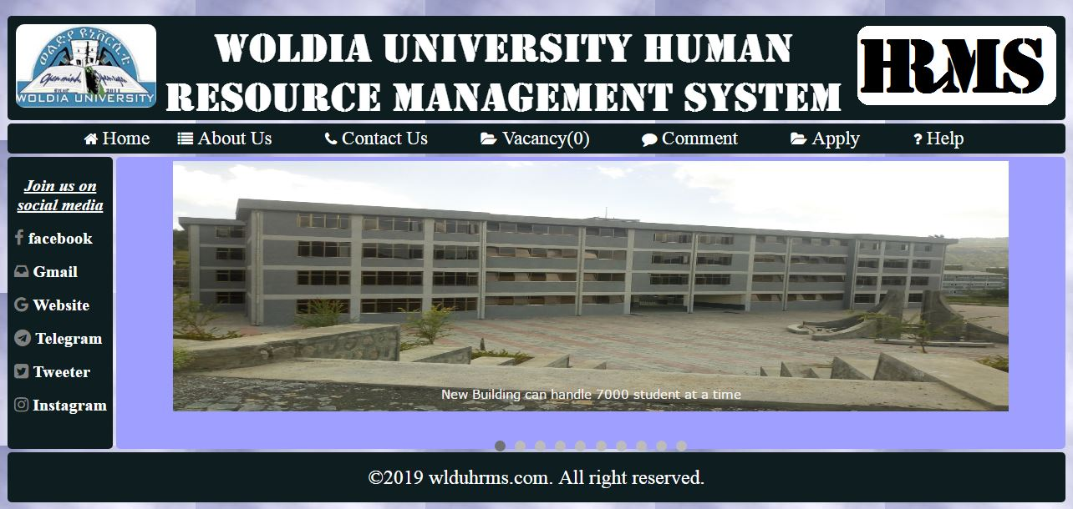

Figure 3.10 applicants home page interface

**Interface of WLDU HRMS employee leave request page**

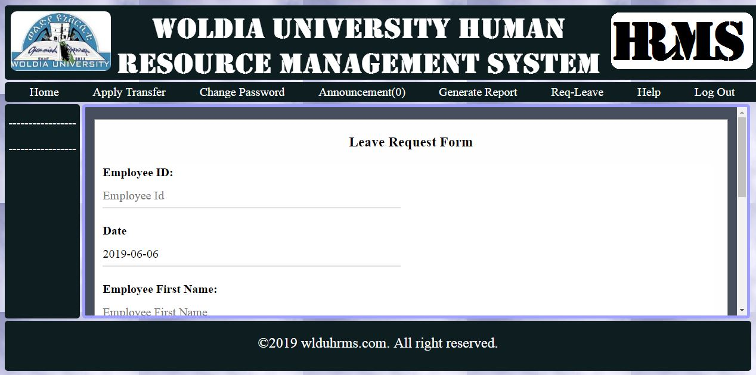

Figure 3.11 employee leave request page interface

**Interface of WLDU HRMS college dean employee request page**

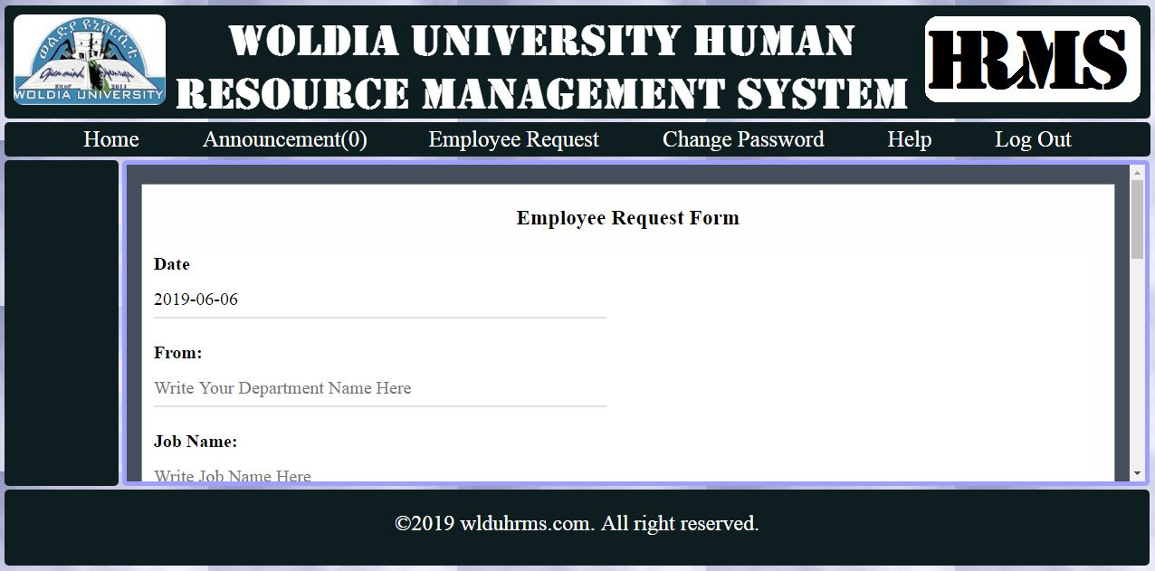

Figure 3.12college dean employee request page interface

**Interface of WLDU HRMS manager report list page**

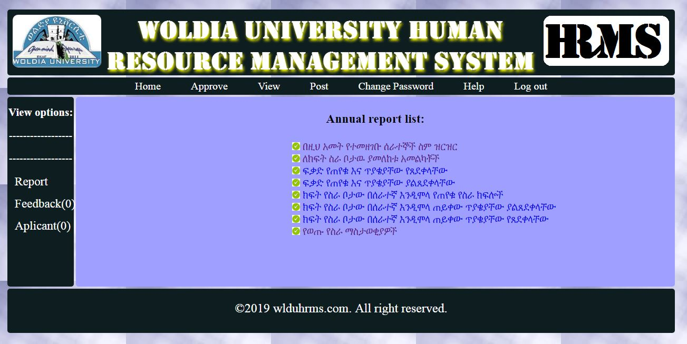

Figure 3. 13 manager report list page interface

**Interface of WLDU HRMS manager registered applicant list page**

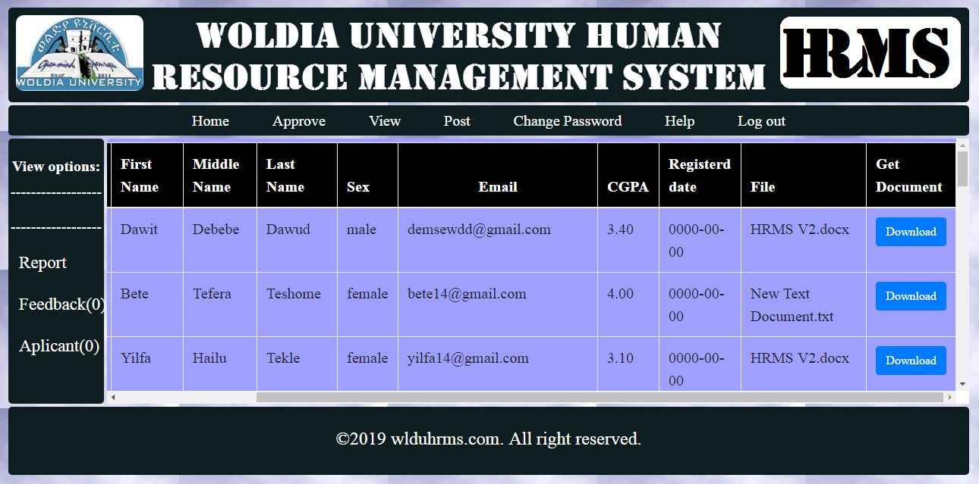

Figure 3. 14manager view registered applicant page interface

**Interface of WLDU HRMS manager annual registered employee system report page**

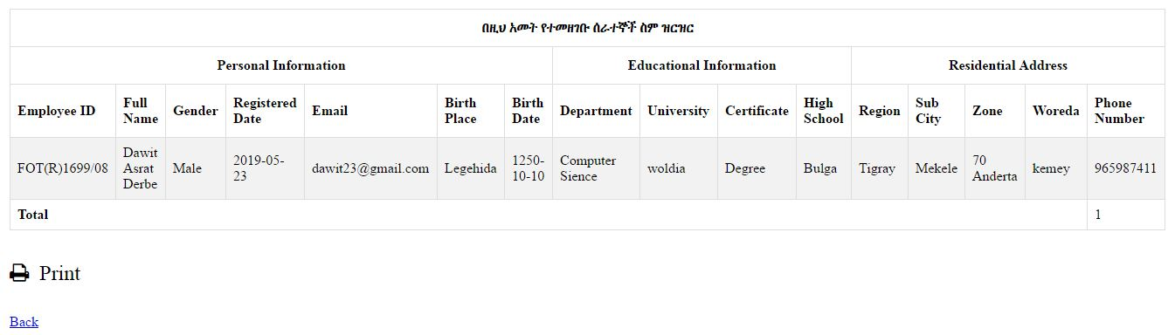

Figure 3. 15annual registered employee report page interface

# **CHAPTER FOUR**

# **IMPLIMENTATION AND TESTING**

## **4.1 Implementation**

### **4.1.1 Introduction**

In this chapter we mainly focuses on the implementation part, implementation concerned with the techniques to develop the system, algorithm for the system, code samples of the system, some testing techniques are briefly described in this part of documentation. This project is implemented using Hypertext markup language **(**HTML**)** and Hypertext Preprocessor (PHP) by using Cascading style sheet (CSS) for style and Java script (JS). Also we used different plugins like data table and different frame works like bootstrap, Ajax, jQuery, freeze header, and other since it helps us much to decrease the difficulties of coding and to get the best features from them. The selection of HTML and PHP is based on the version of the system since this system is web based and also it is the most easy and suitable language than other language we know and because of it is platform independent. In this chapter the sample coding for implementation and testing ways has been described.

### **4.1.2 Coding Standards**

* We have write comments in the coding and documentation. ...
* We have written readable yet efficient code. ...
* Use helper methods. ...
* We have written test cases. ...
* We have written readable yet efficient code. Conform to the coding standards of our current project.
* We use IDE's drop-down menu. ...
* APIs are handy.

### **4.1.3 Sample source code**

#### **Sample source code for sending feedback and counting the unread feedbacks from the database**

<?php

class Comment{

function Count()

{

$con=mysql_connect("localhost","root","");

mysql_select_db("wldu_hrms",$con);

$num=0;

$a=mysql_query("select * from vacancy where Status = 'open'") or die(mysql_error());

while($rows1=mysql_fetch_array($a))

{

$num=mysql_num_rows($a);

$num=$num++;

}

return $num;

}

function SendFeedback()

{

if (isset($_POST['submit']))

{

$c=$_POST['email'] ;

$e=$_POST['subject'];

$name=$_POST['firstname'];

if($c!="" && $e!="" && $name!="")

{

include("conn.php");

$insert=mysql_query("insert into feedback ( name, email, comment ) values('$name','$c','$e')");

if($insert==true)

{

echo '<Script>alert("Your Comment Successfully Sent!")</script>';

}

else

{

echo '<Script>alert("Unsucessful Something went wrong!")</script>';

}

}

}

}

}

$comment = new Comment();

$comment->SendFeedback();

?>

#### **Sample source code for administrator home page interface**

<?php

session_start();

if(!isset($_SESSION['user'])){

?>

<script> alert("You are are not logged in please login first!!") </script>

<?php

header("location:../login.php");

}

?>

<!DOCTYPE html>

<html>

<head>

<title>WLDU HRMS</title>

<link rel="stylesheet" type="text/css" href="hrmsstyle.css">

<link rel="icon" type="img/png" href="image/logo.jpg"/>

<style>

@media (min-width: 1365px) and (max-width: 1400px){

#h1-heading{

/*display: none;*/

font-size: 50px;

color: red;

font-family: arial;

}

}

@media (min-width: 1000px) and (max-width: 1365px){

#h1-heading{

/*display: none;*/

font-size: 35px;

color: red;

font-family: arial;

}

}

@media (min-width: 880px) and (max-width: 1000px){

#h1-heading{

/*display: none;*/

font-size: 30px;

color: red;

font-family: arial;

}

}

@media (min-width: 400px) and (max-width: 880px){

#h1-heading{

/*display: none;*/

font-size: 20px;

color: red;

font-family: arial;

}

}

@media (min-width: 300px) and (max-width: 400px){

#h1-heading{

/*display: none;*/

font-size: 15px;

color: red;

font-family: arial;

}

}

@media (min-width: 20px) and (max-width: 300px){

#h1-heading{

/*display: none;*/

font-size: 9px;

color: red;

font-family: arial;

}

}

#left-side-menu ul{

text-align: left;

border-radius: 5px;

padding: 0px;

list-style-type: none;

margin-left: 0px;

margin-right: 0px;

float: left;

margin-top: 4px;

margin-bottom: 4px;

background-color: rgb(14,29,31);

}

#left-side-menu ul li{

margin-left: -15px;

}

#left-side-menu ul li a{

text-decoration: none;

font-family: times new romans;

font-size: 22px;

color: white;

padding: .5em 1.3em;

transition:2s,transform 0.5s 1s;

cursor: pointer;

text-align: left;

}

#left-side-menu ul li a:hover{

font-family: times new romans;

font-size: 22px;

color: black;

background-color: white;

border-radius: 10px;

transform: rotate(360deg);

margin-left: 0px;

margin-right: 0px;

}

</style>

</head>

<body>

<div id = "header">

<img class = "hrlogo" src="image/HR.png">

<img class = "wldulogo" src="image/logo.jpg">

<!--<img style="vertical-align: center;" class = "header-image" src="image/Header_image2.png"> -->

<h1 id = "h1-heading" style="text-align: center;font-weight: bolder;font-family: Stencil;color: white;padding: 10px;"> Woldia University Human Resource Management System</h1>

</div>

<div id = "navbar">

<ul>

<li><a href="home.php"> Home </a> </li>

<li><a href="create_account.php"> Create account </a> </li>

<li><a href="activate.php"> Activate </a> </li>

<li><a href="activate.php"> Deactivate </a> </li>

<!-- <li><a href="update_account.php"> Update account </a> </li> -->

<li><a href="change_password.php"> Change password </a> </li>

<li><a href="help.php"> Help </a> </li>

<li><a href="logout.php"> Log out </a> </li>

</div>

<div class = "main">

<div align="center" style="margin-top: 50px;">

<img src="image/user.jpg" width="150" height="150">

<?php

echo "<table>";

echo "<tr>";

echo "<td>";

echo ' <b>Welcome: </b>' . $_SESSION['role'] . " " . $_SESSION['name'];

echo "</td>";

echo "</tr>";

echo "<tr>";

echo "<td>";

echo '<b>Email: </b>' . $_SESSION['email'];

echo "</td>";

echo "</tr>";

echo "</table>";

?>

</div>

</div>

<div id = "left-side-menu">

</div>

<div id = "footer">

&copy;2019 wlduhrms.com. All right reserved.

</div>

</body>

</html>

## **4.2 Testing**

From different testing methodologies we have used the following one to ensure that the proposed system is met its goal or to identify any error/problem and to take an appropriate measure.

### **4.2.1 Test type**

***Unit Testing***

In unit testing we divided the general system in to number of modules or components. Since we have functionalities which is a collection of the use case's that we have test each module separately whether each use case or components works correctly or not. We have used this testing technique to verify the functionality of a specific section of code, usually at the function level. So we enforced to use this method of testing to ensure that the specific function is working as expected.

***Integration Testing***

Here we used this type of testing to test whether one of our modules like administrator, manager, applicant, record officer, college dean or employee modules is integrated to each other or not. In general, we have used this testing to verify the interfaces between components against a software design. We used to expose defects in the interfaces and interaction between integrated components (modules)

***System Testing***

This is the third testing techniques that we have used it at the end of the implementation. It helps to ensure whether it met the requirement of the organization and the client or not.

### **4.2.2 Overview of Manual testing automated testing**

Since our system is web based Human resource management system, everything important for the user will be explained and implemented while giving short training when the system is deployed. Rather there is no need of preparing full user manual because it is only deployed (hosted) on a single machine that is server. But the team has prepared a link on the system that is help full for new user; that can guide users when they get any confusion during their usage. So, the following is the common question most users want to get the answer to have access to these applications.

**How to use our developed Web Based Human resource Management system/application?**

* First browse the system using internet connection. Here you have two options if you are applicant you should have to browse the applicant’s page by entering its domain name or if you are other actors who have a privilege on the system browse the other application using its domain name.
* Then if you are applicant no need to login you can simply get any information that you want like viewing vacancies and applying to those vacancies and other.
* If you are non-applicant user that use the system you need to login by entering the correct username and password.
* If your username and password is correct your privilege will be given to you.
* Then perform any actions that you want to do on your privilege.

### **4.2.3 Test Plan**

Test plan is document describing software testing scope and activities. It is the basis for formally testing any software/products in a project. A document describing the scope, approach, resources and schedule of intended test activities. It identifies amongst others test items, the features to be tested, the testing tasks, who will do each task, degree of tester independence, the test environment, the test design techniques and entry and exit criteria to be used, and the rationale for their choice, and any risks requiring contingency planning. It is a record of the test planning process.



Figure 4.1Test plan

### **4.2.4 Test case specification**

**Test name:** Login user

**Test Description:**

This login test is used to check whether any one access the system or only those authorized user have an access to the system

Test case Name: Login

Table 28 Login Test Description Table

|  |  |  |  |  |
| --- | --- | --- | --- | --- |
| **Action** | **Test Procedure** | **Input** | **Expected result test** | **Pass/fail** |
| Test login system | The system user should click login link. | User’s appropriate username and password. | The page that enables the user to perform their action is displayed. | Pass-the user can perform activities based on his/her privileges. |
| Log-in Page screen is displayed |
| User enters his/her user name and password. |
| Incorrect username and password | “Please Enter correct username and password “ message display, | Fail – the user can’t access the pages. |

**Purpose of test**: Authentication test

**Testing objects**: **Login checking**

**Test focus**: correct username and Password validation

**Test Process**

1**. Starting condition**

* The system user should click login link.
* The login Page will be displayed.

2. **Input**

* The user enters his/her username and password
* Then clicks **login button**.

3.  **Expected result**

* At the time of login, if the username and password are valid user page is displayed and accessible to the customer.

4. **Failure Condition**

* If user enters invalid username and password, please enter valid username and password message is displayed.

**Test name:** Create account

**Test Description:**

This create account test is used to check an account is created by the administrator without any challenges or not.

Test case Name: Create account

Table 29 Create account Test Description Table

|  |  |  |  |  |
| --- | --- | --- | --- | --- |
| **Action** | **Test Procedure** | **Input** | **Expected result test** | **Pass/fail** |
| Test create account system | The administrator should click create account link. | User’s appropriate username, name, role, email, and password and confirm password. | The user account is created successfully. | Pass-the user can enter in to the system based on the account created before. |
| Create account Page is displayed. |
| The administrator will fill all necessary information to create the account. |
| Incorrect fill of the fields. | “Please fill the required fields “ message display, | Fail – the user account will not be created and the user cannot access the page. |

**Purpose of test**: Account creation test

**Testing objects**: **Create account checking**

**Test focus**: correct data fill for create account validation

**Test Process**

1**. Starting condition**

* The administrator should click create account link.
* The create account page will be displayed.

2. **Input**

* The administrator enters appropriate username, First name, role, email, and password and confirm password.
* Then clicks create button.

3.  **Expected result**

* At the time of create account, if the filled data are valid account will be displayed and user can login to the system.

4. **Failure Condition**

* If user enters invalid data, please enter data message is displayed.

### **4.2.5 Test Report**

In login test after the user is authenticated the expected user page is displayed for example when the user is the administrator and if he or she is entering the valid username and password the expected screen will be displayed. The screenshot is given below for the admin page after he or she is entering the correct username and password authenticated by the system. Also in create account test after the administrator creates the account by filling the correct required fields the following page is displayed

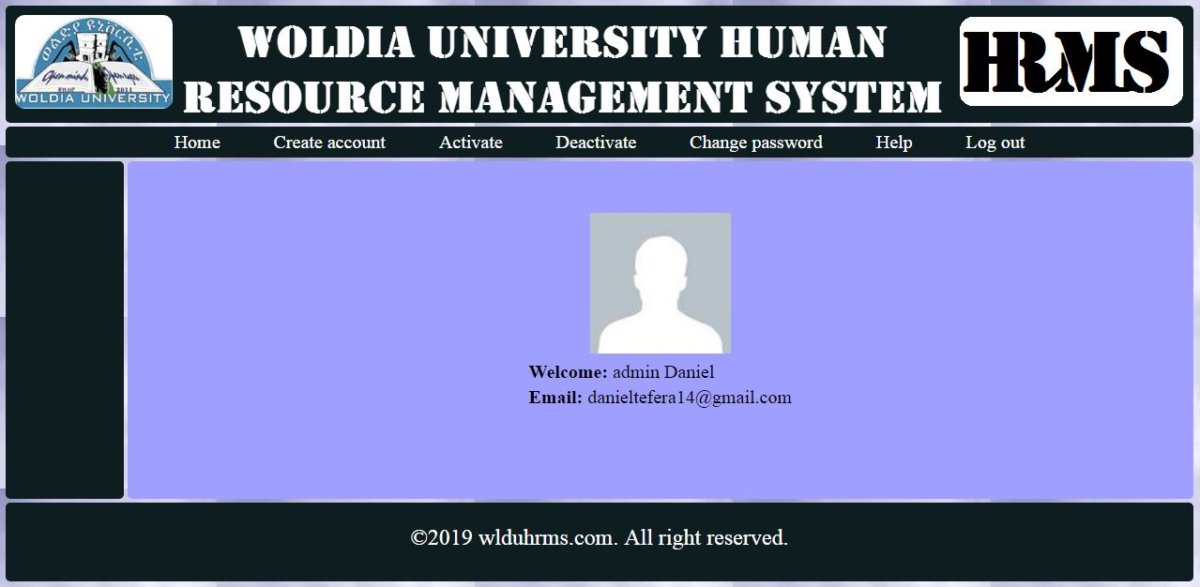

Figure 4. 2 Admin page after login

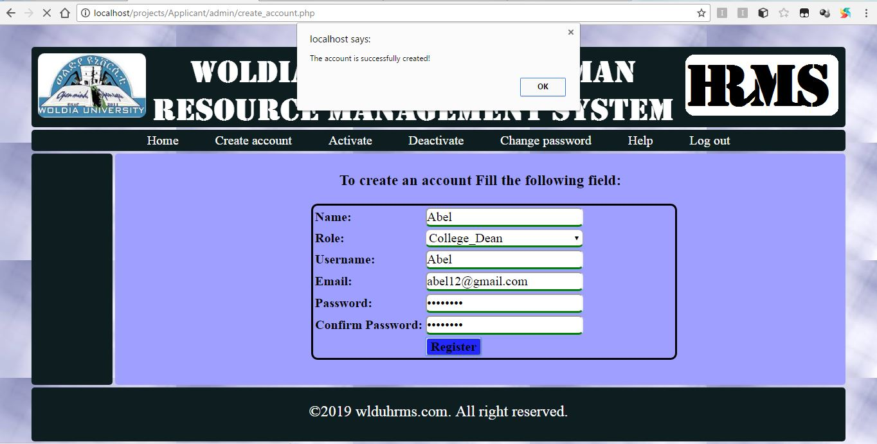

Figure 4. 3account created successfully page after test

# **CHAPTER FIVE**

# **CONCLUSION AND RECOMENDATION**

# **5.1 Conclusion**

Woldia university Human resource management system is one of the most important systems in Woldia University. The existing system has been performing all its tasks manually. So the users of the system were facing many challenges to use the system; For Instance, wasting energy and time.

So by taking these problems into consideration the group members developed a Web based human resource management system for Woldia University. This new system solved many problems. Our main aim of the project in solving this problem by:

* Providing brief and secure communication
* Minimizing the time required to perform task
* Providing sufficient security
* Minimizing the wastage of materials

# **5.2 Recommendation**

The system we have developed is an application web based system it needs a skilled person to work with the system. So, we recommend the system should be required the responsible and skilled person. We highly recommend the system’s resource should be kept in highly safe and favorable condition. If someone wants to enhance this system it is highly recommended that to add some other functionality like attendance system, payroll system, employee promotions system and make the system to support local language like Amharic and other.

## **Appendix**

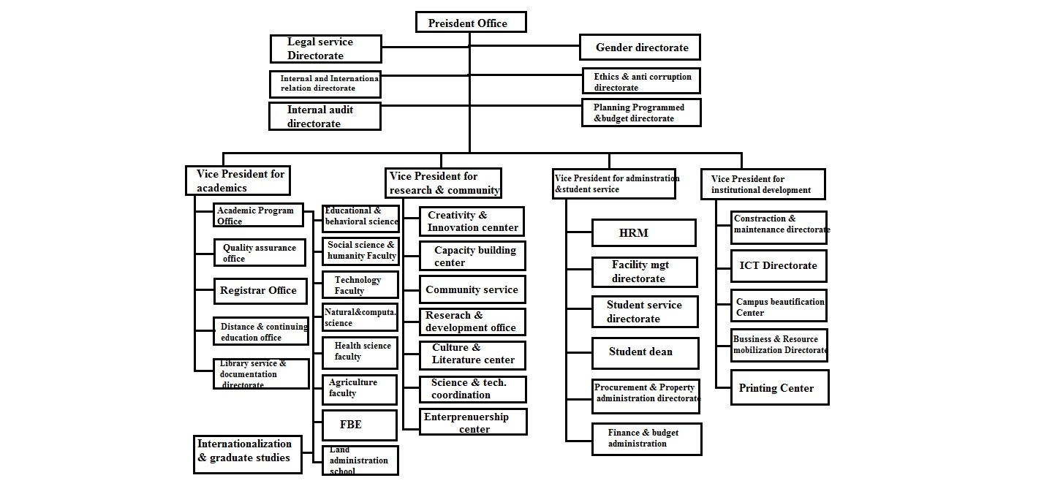

### ***Appendix 1 Organizational structure of WLDU***

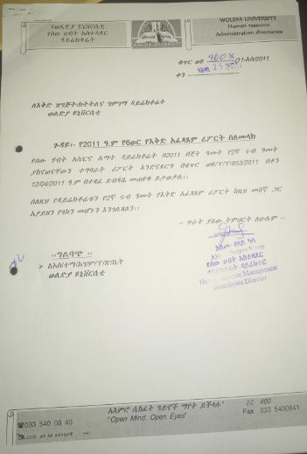

### ***Appendix 2 Semester report***

Employee Name Frist ----------------- Middle ----------------- Last--------------------

Birth Date day, month, Year-------------------------- Place of birth--------------------

Region------------- Zone------------------ Woreda-------------------

Nation/nationality---------------------------------------

Nationality----------------------------------- Sex---------------------

Address Region---------- City------------ Zone------------- Woreda------------ Kebele----------

Phone No. ----------------- House No.----------------------

Marital statusmarried------------ single---------- divorced --------------------

In case of emergency Full name----------------------------------- Region---------------- Zone-----------

Woreda-----------------Kebele----------------- phone number--------------------

Educational status---------------------Special skill------------------------- Experience------------------------

EMPID----------------------------- Experience--------------------------------------------------------------

Date of employment---------------------------------- Type of employee-------------------------------

Acknowledgment and rewards (if any) --------------------

Assurance of employeeNameand Signature-------------------- job position--------------- date---------------

Assurance officer name---------------signature----------------job position---------------date------------------

A

### ***Appendix 3 Employee registration forms***

 ***Appendix 4 Work flow for employee recruitment***

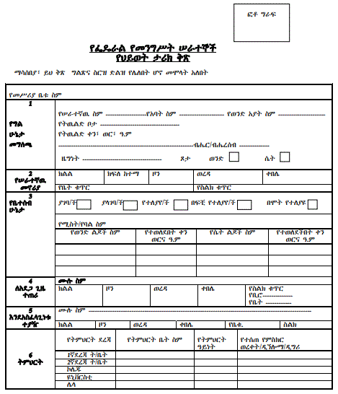

### **Appendix 5[10] Employees diary form**

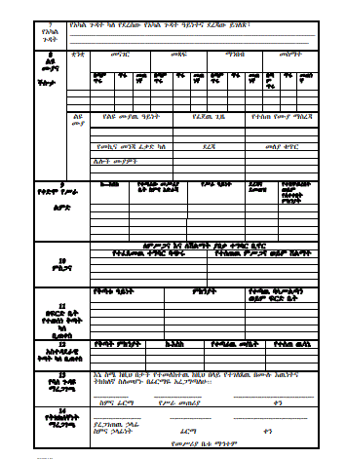

Appendix 6 [10] Employees diary form 2

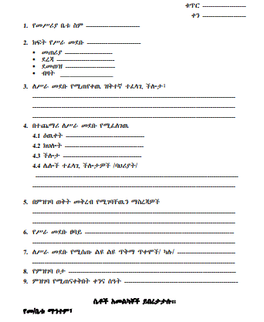

Appendix 7 [10] Vacancy form

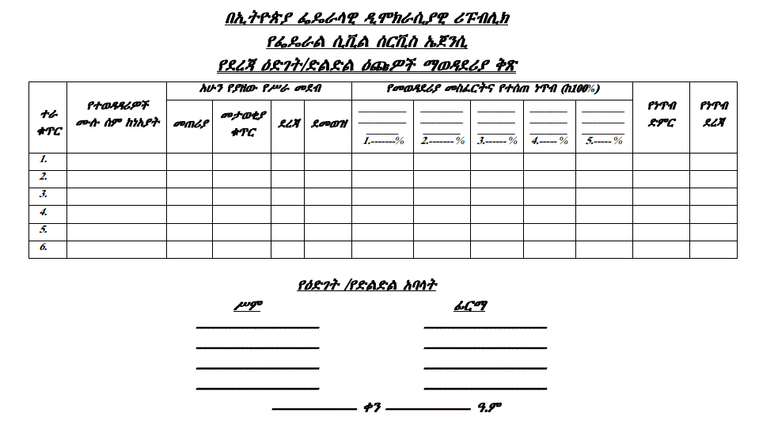

Appendix 8 [10] Level development competition form

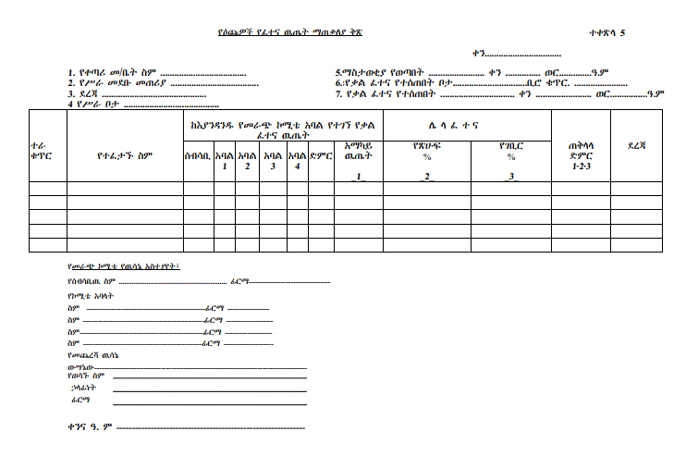

Appendix 9 [10] Applicants exam result conclusion form

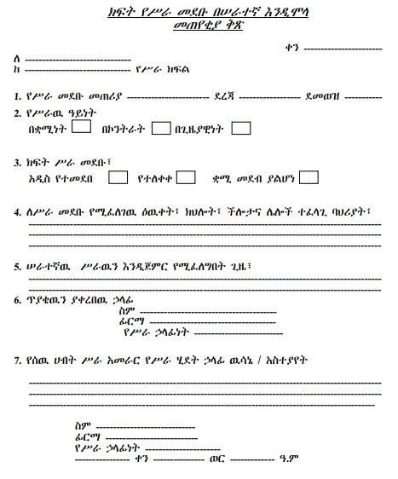

Appendix 10 [10] Forms to ask the job place to be filled

## **References**

**[1]** Vision 360 IT consulting, “Human resource management system” retrieved from http://www.it.vision360.co.in, last accessed in December 9, 2018.

**[2]** Abiyot Kefal , Alemayehu Demeke , Alemtsehay Bedasa , Burkitu Elias , Kidist Wendemu, “Human resource management system for sodo referral hospital” Wolaita sodo University college of natural and computational science department of computer science and IT, June 05, 2015.

**[3]** Anteneh, ”Fundamental of software engineering chapter 2 software process handout” woldia university faculty of technology department of computer science, january14, 2017.

**[4]** Addis abeba software developer”, Addis Abeba university human resource management system” retrieved from http://www.aau.edu.et/hrms, last accessed in December 9 / 2018.

**[5]** AASTU software developer,” Addis Abeba science and technology university human resource management system” retrieved from http://www.aastu.edu.et/hrms, last accessed in December 10 / 2018.

**[6]**Guru99 “Comparison of various SDLC models” retrieved from https://www.guru99.com/compare-waterfall-vs-incremental-vs-spiral-vs-rad.html, last accessed in December 27, 2018.

**[7]**[Wikimedia Foundation, Inc.](https://www.wikimediafoundation.org/)“Structured approach”, https://en.wikipedia.org/wiki/Structured_programming , last accessed in December 27, 2018.

**[8]** Bernd Bruegge and Allen H.Dutoit, “Prentice object oriented software engineering using UML, Pattern and java” Third edition, 2012.

**[9]** Kedir, “Intermediate database management system handout”, woldia university faculty of technology department of computer science, unpublished, 2008.

**[10]** HPR, “Federal negarit gazeta of the federal democratic republic of Ethiopia federal civil servant proclamation, Proclamation No.515/2007” AA, 2007.